Gamma Beta Newsletter
The Delta Kappa Gamma Society International
April, 2019

March Meeting Highlights

Gamma Beta met at OH Bryans Steakhouse in Hartselle. OH Bryans was very accommodating for our dinner/meeting. Members were encouraged to make a simple Easter craft that can be used for an Easter “happy”, decoration, or place card holder.

Don’t blink, they’ll start multiplying!

Possible meeting/programs was discussed for the next year. Dues were collected. If you were not present at the March meeting, you will be contacted by Dottie to send in your dues for the next membership year. NOTE: This is a change beginning the 2019-2020 membership year.
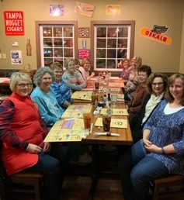
Membership at OH Bryan’s Steakhouse

Celebrating Valerie’s 39th Birthday, Cakes are compliments of Brenda Berryman

Alabama State News

The Leadership Seminar will be held June 4-5, 2019 at the Marion Military Institute in Marion, AL. Speaking from experience, this is a very worthwhile, rewarding event. Sisters that I met during my weekend at a leadership seminar are close to me to this very day. It is a great way to get to know your sisters across our wonderful State. It is my sincere wish that we will have representation at this seminar from our chapter. You will not regret the sacrifice of your time not to mention all that you will gain from your participation. The application will be attached to the email for this newsletter.

Gamma Beta Website

Send photos to her at dmcrow56@gmail.com.
http://gammabetachapter.weebly.com/

April
1st Jennie Roberts
21st Ginger Richey
May
23rd Dottie Donahue
June
27th Wendy Duffey
July
12th Wanda Duncan
29th Betty Vaughn
29th Debbie Ferguson

April Meeting
April 4,2019
4:00 PM

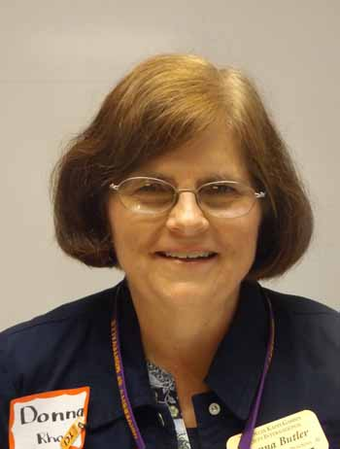
Donna Butler Alabama State President
Walter Jackson Elementary School
90 Park St.
Decatur, AL 35601

Devotion: Mu Chapter

Business:
- Collection of Dues
- Achievement Awards

Program:
- Alabama State President Donna Butler
- Initiation of new members – Donna Butler
- Founders Day Program – Lane Hampton

We are hostesses for this event. Dottie Donahue will be contacting you concerning food for this joint meeting.

2018-2019 Meeting Dates

- June 4-5 2019 Leadership Seminar, Marion, AL.

