Gamma Beta Newsletter
The Delta Kappa Gamma Society International
April, 2021

Member News
Hope all our active teachers (Dawn Carroll, Wendy Duffey, Debbie Ferguson, Lane Hampton, Beth Milner, Karen Parmer, Ginger Richey, and Jennie Roberts) have/had a safe, fun, relaxing spring break!

March Meeting Highlights
Gamma Beta met at West Hartselle Baptist Church on February 4th at 4:30 PM. In attendance were:
Jeanne Ellen Stroh, Beth Milner, Valerie Powell, Caroline Ellinger, Brenda Berryman, Debby Crowell, Sherri Peck, Lane Hampton, Karen Parmer, Jennie Roberts and Dottie Donahue.

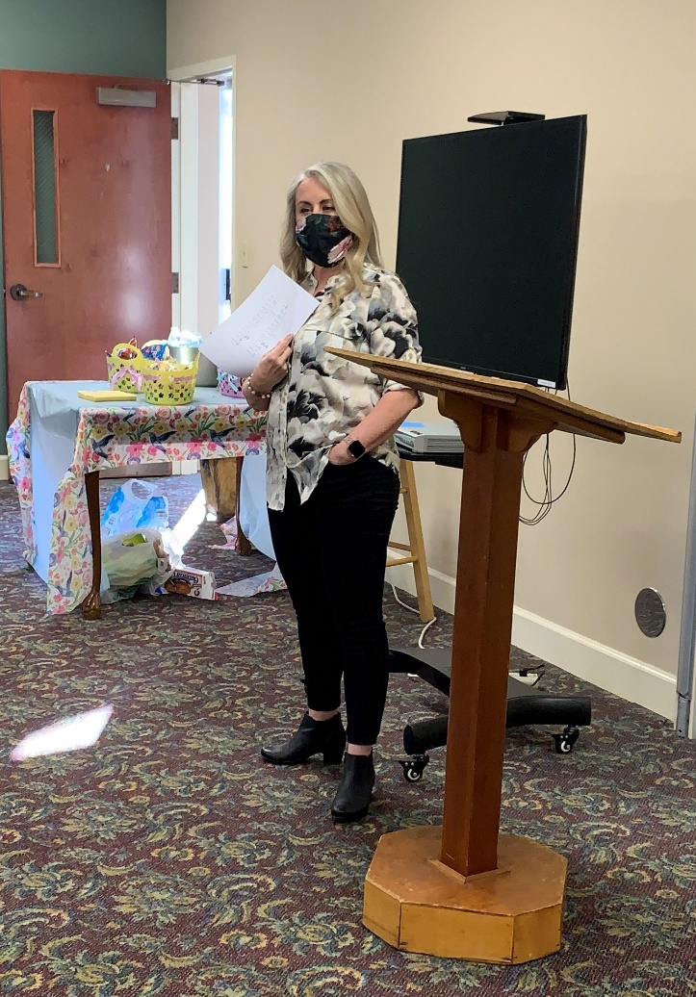
Jennifer Bell from Inspired Health informed our chapter on the importance of breathing for good health. We even had some guided practice, masks in place of course.

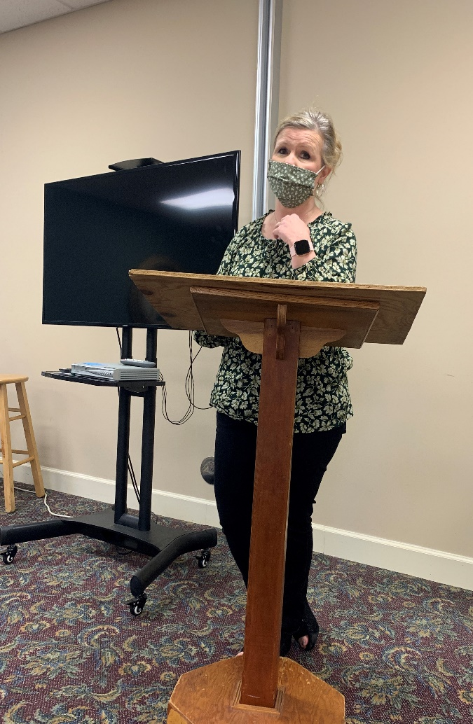
Karen Parmer delivers another inspiring devotional.

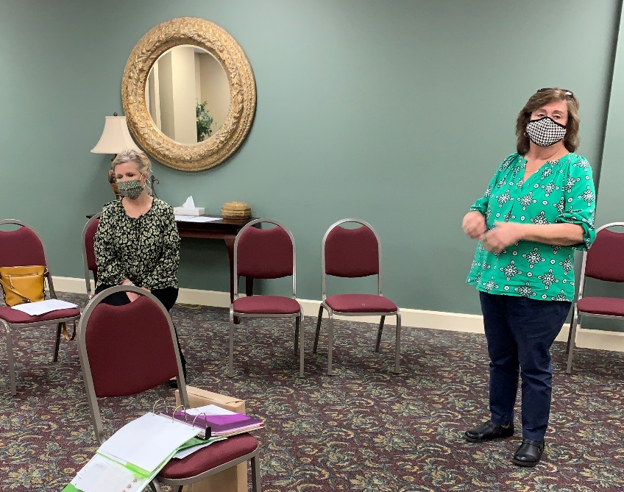
We glad to see member Brenda Berryman come back to a meeting after her self-imposed isolation to protect her new Grand Daughter.

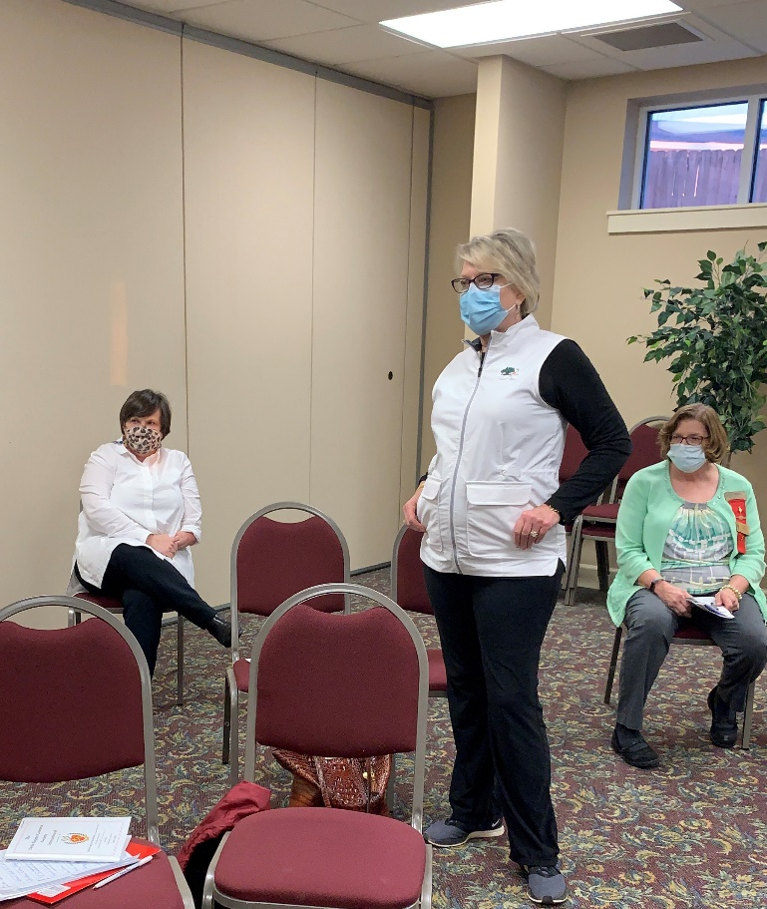
Jennie, Sherri, and Valerie are more than adequately socially distanced during the March meeting. Our facility at West Hartselle Baptist can accommodate our whole membership simply by opening up the partition between rooms. A special thanks to Lane Hampton and Sherri Peck for setting up the meeting space each month.

Alabama State News

Our Alabama State Convention will be held on May 22nd at the Embassy Suites in Montgomery. Let’s get a group to go to support our president! You can access the registration form by following this link: https://alabamadkg.weebly.com/uploads/1/2/6/3/126383678/2021_alabama_state_convention_registration_form_revised.doc

The Alabama State Leadership Conference will be June 12 – 13 at Jacksonville State. If you have not attended a leadership conference this is an event you do not want to miss. More information will be forthcoming in the next Alabama News.

Gamma Beta Website
Send photos and information to Debby at dmcrow56@gmail.com.
http://gammabetachapter.weebly.com/

April
1st Jennie Roberts
21st Ginger Richey
May
23rd Dottie Donahue
June
15th Debbie Wiggins
27th Wendy Duffey
July
12th Wanda Duncan
29th Betty Vaughn
29th Debbie Ferguson
August
7th Beth Milner
17th Lane Hampton

April Meeting
April 8, 2021
4:30 PM
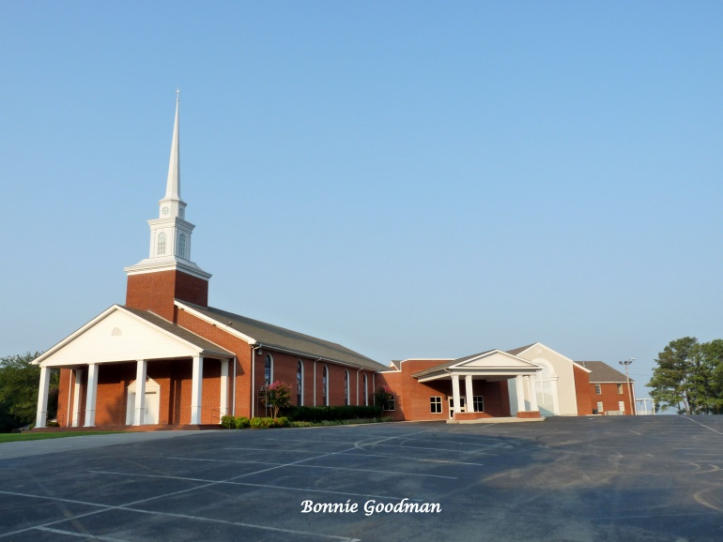
West Hartselle Baptist Church
1640 Main Street W.
Hartselle, AL 35640
Devotion: Wanda Duncan
Business:
- Collection of Dues
Program:
- Founders’ Day Program
- Alabama State President – Teresa Noell

Teresa Noell

Hostesses: Valerie Powers chair, Karen Parmer, Wendy Duffey, Beth Weinbaum, Corkey Vann

REMINDER: Dues for active members are $80 and $45 for reserve members. If you are unable to make the April meeting and HAVE NOT paid your dues yet please mail them to Dottie Donahue, 15627 Line Rd., Athens, AL 35613.

2021 Chapter Meetings and Important Dates

- April 1, 2021 – Deadline for submitting application for the Alabama State Scholarship
- April 8, 2021 – Gamma Beta Chapter Meeting at West Hartselle Baptist Church – 4:30 PM
- May 22nd - Alabama State One Day Convention – Embassy Suites, Montgomery
- June 12-13, 2021 – Leadership Weekend at Jacksonville State University

