Gamma Beta Newsletter
The Delta Kappa Gamma Society International
April 2022
Member News

Please continue to keep Debbie Wiggins in your prayers. Debbie has decided to remain at NHC Moulton instead of trying to return to Morningside. As of now, she’s still in 107B but will move to the skilled nursing area upstairs when a room becomes available. It was a hard decision, but Debbie thinks this is best for her care.
300 Hospital St.
Room 107B
Moulton, AL 35650

Please remember that dues must be paid at the next meeting. Regular Dues are $80 and Reserve Dues are $45.
If you won’t be at the meeting on April 7, then please mail your dues to:
Dottie Donahue
15627 Line Road
Athens, AL 35613

March Meeting Highlights
Members present during the March meeting at Keramos Ceramics were Lane Hampton, Sherri Peck, Jeanne Ellen Stroh, Beth Milner, Wanda Duncan, Valerie Powell, Brenda Berryman, Dottie Donahue, Carolyn Ellinger, Jo Ann Sneed, and Debby Crowell.
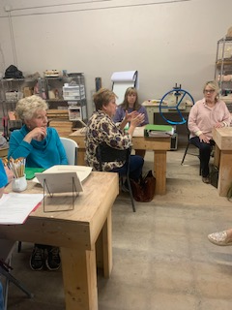
Jeanne Ellen conducts the business part of the meeting while Jo Ann, Beth, and Sherri listen.

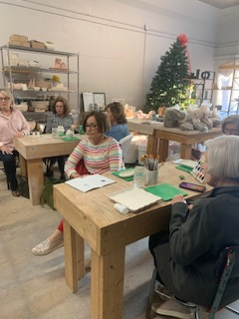
Sherri, Dottie, Wanda, Brenda, Valerie and Carolyn vote on accepting the 2022-2024 slate of Gamma Beta Officers

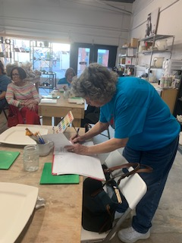
Lane finishes the minutes of the meeting while members wait on instructions to complete their ceramic project

Business meeting notes:
- Donations were collected for Alabama State’s project Eagles’ Wings
- The 2022-2024 Gamma Beta nominated slate of officers were voted upon and approved by the members.
- Information was given on how the fundraising silent auction would be conducted during the April joint meeting with our sister chapter, Mu.

Gamma Beta Website
Send photos and information to Debby at dmcrow56@gmail.com.
http://gammabetachapter.weebly.com/

Alabama State
One Day Officer Training is June 3, 2022 at Dalraida Church of Christ. June 3rd is a Friday. Registration forms are available through the website and Sister Network. Officer training replaces district meetings. Chapter officers and committees will be trained for the next biennium. Other workshops will be available for members that are not officers. The cost of the workshop is $25 which includes lunch.

Weekend of Wonder (WOW) will be in Muscle Shoals October 14-16, 2022. This is a FUN event while getting together with our Alabama State sisters.

April
1st Jennie Roberts
21st Ginger Richey
May
23rd Dottie Donahue
June
15th Debbie Wiggins
27th Wendy Duffey
July
12th Wanda Duncan
29th Betty Vaughn
29th Debbie Ferguson
August
7th Beth Milner
17th Lane Hampton
September
5th Corkey Vann
6th Dawn Carroll
14th Brenda Berryman

April Meeting

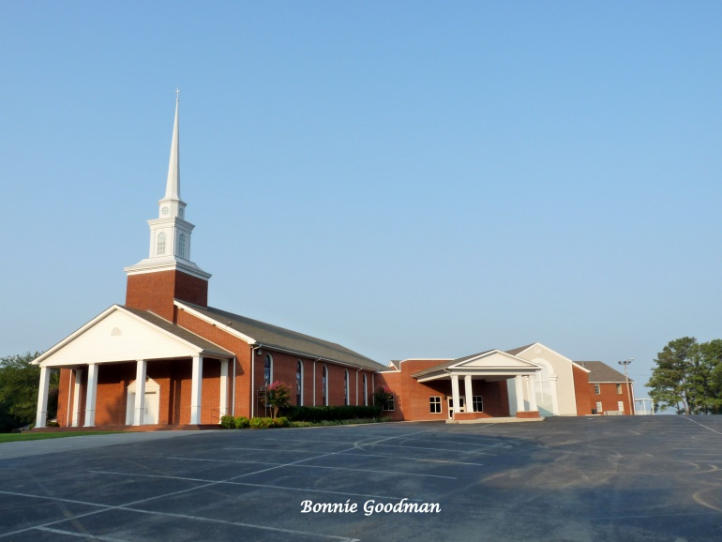
April 7, 2022
4:00 PM
Thursday
West Hartselle Baptist Church
1640 Main St. W.
Hartselle, AL 35640

Devotion: Carolyn Ellinger
Business:
- Collection of Dues
Program:
- Founders’ Day Celebration
- Alabama State President Penny Christian

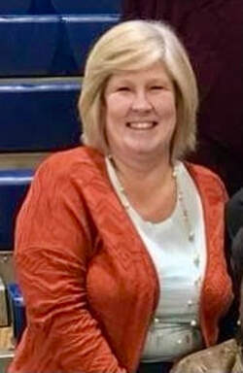

- District 1 Director Carolyn Eck

REMINDERS:
- All members available show up at 3:00 PM to help set-up for the silent auction and refreshment tables.
- Note that this meeting will start at 4:00 PM NOT 4:30.
- Let Dottie know by April 1st what silent auction items you will be donating.
- Bring your silent auction items!!

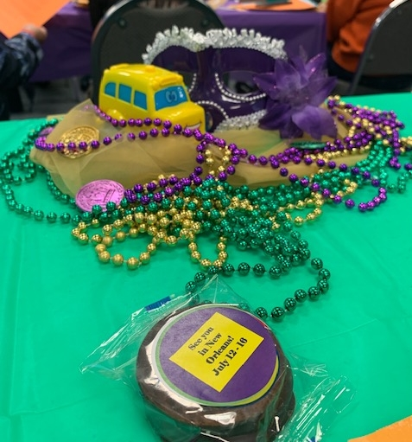

2021-2022 Chapter Meetings and Important Dates

- April 7, 2022 – Gamma Beta Meeting at West Hartselle Baptist Church – 4:30 PM – Founders Day Celebration with Mu Chapter – Penny Christian, Alabama State President
- May 1, 2022 – Achievement Award applications due to Allison Hill
- June 3, 2022 – Officer Training Day for all new chapter officers at Delraida Church of Christ, Montgomery
- July 12 – 16, 2022 – International Convention in New Orleans
- October 14-16, 2022 – WOW – Muscle Shoals

