Gamma Beta Newsletter
The Delta Kappa Gamma Society International
August 2023

Gamma Beta Member News
Valerie Powell and her husband have moved to Dallas, TX to be closer to their son, daughter-in-law, and three grandchildren ages 8, 6, & 4. Valerie has not resigned from Gamma Beta but will contact the International Headquarters to transfer her membership to a local chapter.

While preparing for the move, Valerie discovered that she had stage 0-1 breast cancer. Surgery was performed on July 11th by Dr. Jason Seale. If radiation is needed that will take place in Dallas. Many prayers are needed for Valerie and her family.

Valerie’s new address is:

2000 Highland Road
Apt. 1104
Dallas, TX 75228

Gamma Beta April Meeting Highlights

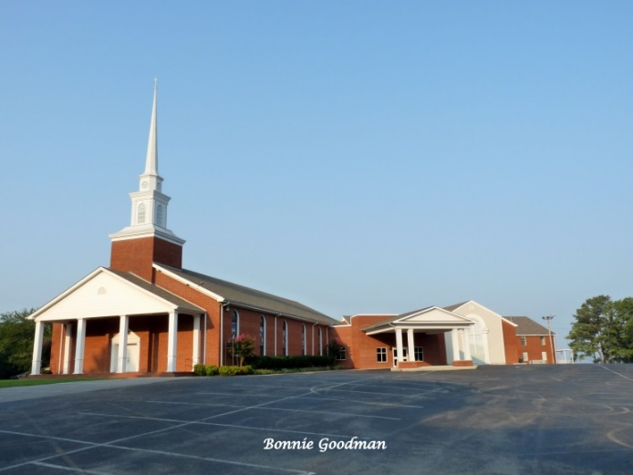

- Gamma Beta and Mu Chapters met together at West Hartselle Baptist Church on April 6th.
- MaryBeth Henry, from Mu, gave the devotional.
- Karissa Lang, principal of Crestline Elementary School in Hartselle, was the guest speaker.
- A silent auction was held at the end of the meeting.
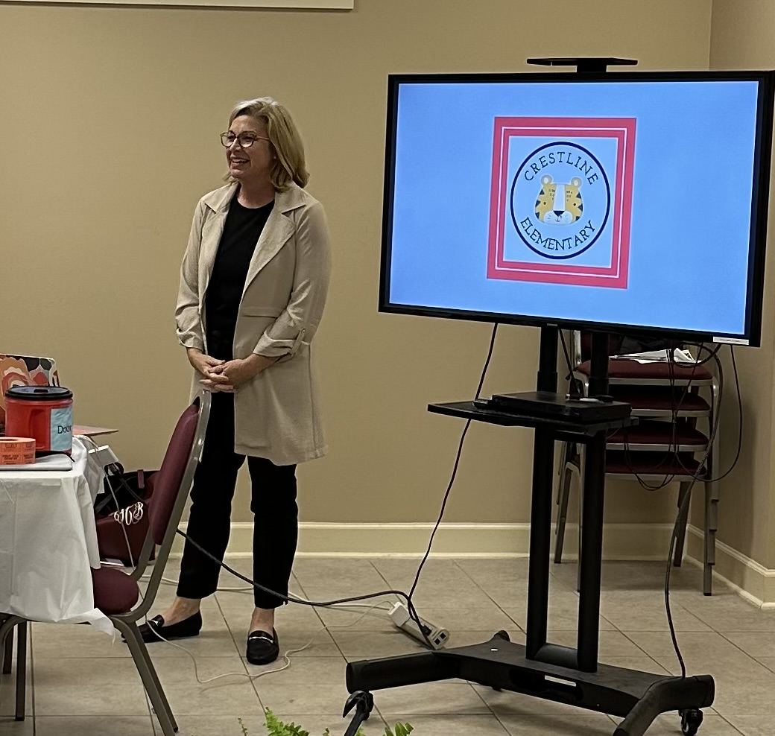
Karissa Lang, NAESP National Distinguished Principal for Alabama Aware, spoke to Gamma Beta and Mu about the challenges that we face in education today.
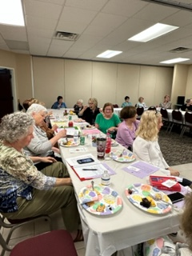
Gamma Beta and Mu listen attentively to Karissa Lang while enjoying the yummy refreshments
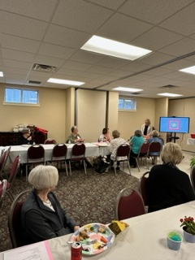
Members listen while Karissa talks about the “new” Crestline Elementary School.
Alabama State
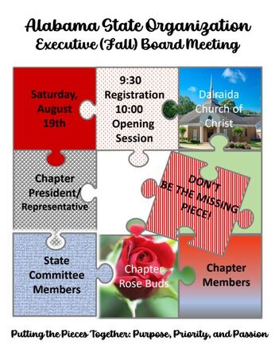
Jeanne Ellen and Debby will be attending the Fall Board meeting on August 19th at Delraida Church of Christ in Montgomery. If you would like to attend, please let Jeanne Ellen know as soon as possible.

Introducing Alabama State’s New President 2023-2025 Biennium

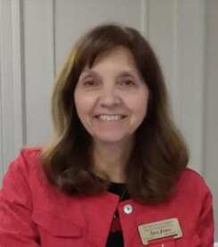
Ann Jones
Delta Beta (II)
annjdkg@gmail.com
Ann Jones has been an active member of Delta Beta Chapter in District II since 2009 where she has served in many positions. On the state level, she has served as a member of the Membership Committee, District II Director, 2nd V.P., and is currently the 1st Vice President and chair of the Educational Excellence Committee. She has benefited from her involvement and attendance at local, district, state, regional, and international conferences and conventions and has led various workshops and sessions. Ann is a retired English teacher from Alexandria High School. She graduated from Texas Woman’s University with a BA in English and earned her MA in Secondary Ed from Jacksonville State University. She has been married for 41 years to Jim. They have lived in five states, have three children, and four grandchildren. Ann is active in her church and her interests include reading, baking, quilting, gardening, and mentoring young women.
The president’s project for this biennium is Autism Support of Alabama. Their mission is to improve services for individuals with Autism Spectrum Disorders and their families through education and advocacy. Autism Support of Alabama (ASA) has been a volunteer organization directed by its Board of Directors for over 20 years. For more additional information regarding Autism Support of Alabama click HERE .
​Putting the Pieces Together: Purpose, Priority, and Passion
2023-2025 Biennium Goals
Work cohesively as a team to successfully promote and continue the history of serving our state.
- Utilize each state committee to carry out their objectives and employ each district volunteer.
- Have each committee analyze the Strategic Action Plan regarding their focus area to plan additional ways to carry out the goals.
- Assess chapter needs with a connection/ care survey and use leadership to assist with areas of concern through resources, workshops, assistance, and visits as needed.
Make increase of membership a “priority” through encouraging induction, retention, and expansion.
- Provide chapters with resources and ideas to reach new members.
- Provide resources to invite potential members using a principal nomination letter.
- Have our Rosebuds share suggestions on ways to reach and retain membership and ways that DKG chapters can serve and support them in their schools.
- Increase our communication avenues to reach our younger, active teachers.
- Train chapters to use those communication formats to best connect with educators.
Focus on the “purposes” of DKG:
- Increase the recognition of chapters and members using various committee awards.
- Utilize workshops/ sessions, articles in the newsletter, resources on the website, or other formats to feature specific purposes.
- Exemplify personal and professional growth as individuals and as valuable “pieces” of Alabama State.
- Be a continual learner of leadership skills, qualities, and techniques.
- Lead with humility, patience, and forbearance.
Increase our “passion” through promoting our project participation.
- Give the World Fellowship globe.
- Have a project display (or video) area at Convention.
- Have chapters that are recognized for projects or programs hold a workshop showcasing their projects/programs and share tips and ideas.
- Contribute to Autism Support of Alabama or local Autism projects for the state project.
- Highlight and support a different project at each state event.
​

August
7th Beth Milner
17th Lane Hampton
September
5th Corkey Vann
14th Brenda Berryman
October
25th Debby Crowell

Gamma Beta Website
Send photos and information to Debby at dmcrow56@gmail.com.
http://gammabetachapter.weebly.com/

2023-2024 Chapter Meeting Dates
- October 5 - Salad Potluck Supper at West Hartselle Baptist
- November 2 - Keramos Ceramics
- December 2 - Brunch and new member initiation at Debby Crowell's home
- Feb. 1 - TBD
- March 7 – Alabama State President Ann Jones and District 1 Director Tamra Counts will visit Gamma Beta at West Hartselle Baptist
- April 4 - Athens State University tour of McCandless Music Hall and Founders Day program

