**Gamma Beta Newsletter**

The Delta Kappa Gamma Society International

December, 2018

**Member News**

New Member

We would like to welcome a new member to Gamma Beta, Karen Parmer. Karen is transferring her membership to Gamma Beta from Mu. We will look forward to getting to know her at our December meeting.

Karen Parmer

203 Belle Meade St. SW

Hartselle, AL 35640

[kmparmer@gmail.com](mailto:kmparmer@gmail.com)

DOB: March 26th

C:\Program Files (x86)\Microsoft Office\MEDIA\CAGCAT10\j0158007.wmf

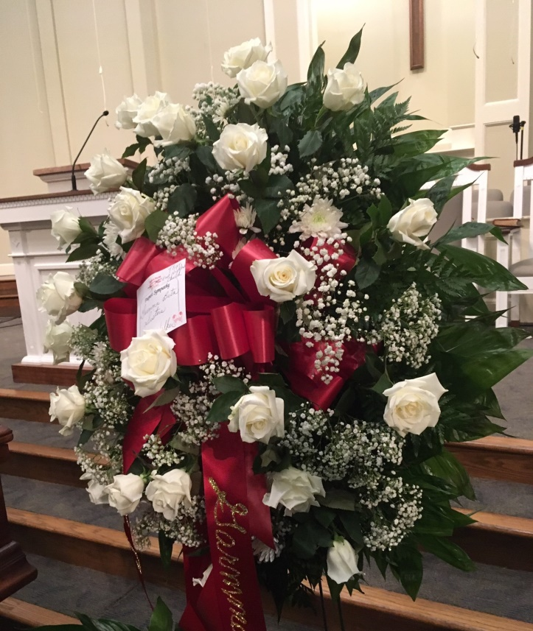

Flowers sent from Gamma Beta for Faye Walker’s Funeral

We shared some special remembrances of Faye at our November meeting. She was a very busy lady! Her family confirmed that Delta Kappa Gamma was a very important part of her life! Faye’s daughter-in-law Jan delivered a box of Gamma Beta history to Valerie recently. She will share this with us at our December meeting.

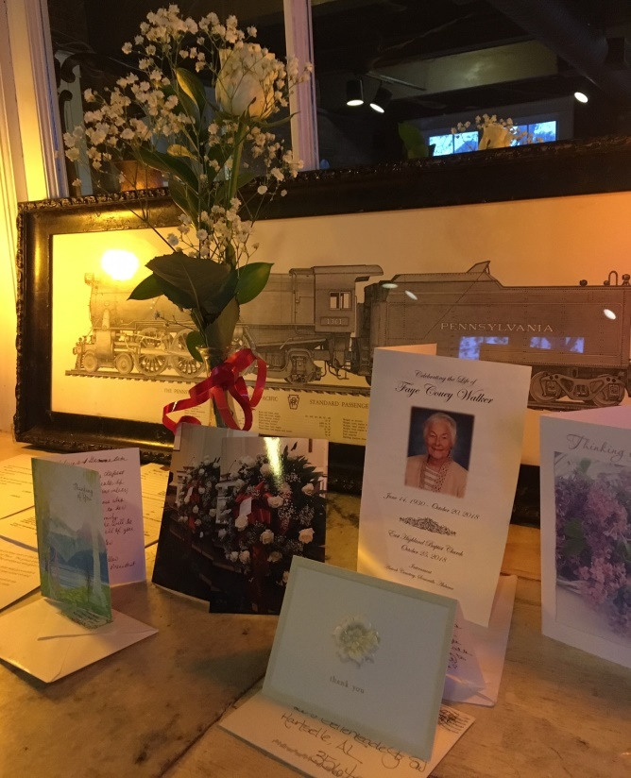

In remembrance of Faye

**November Meeting Highlights**

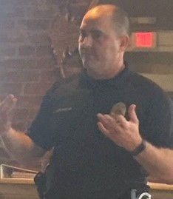

Sgt. Alan McDermond presenting on shopping safety tips.

Our November meeting was held at Freight House Restaurant in Hartselle. Officers Alan McDermond and Tanya Burgess both entertained and awed us with information and stories concerning common crimes while shopping. Key points were to NEVER leave your purse in the car even if it is not in sight, don’t leave your purse on your shopping cart, be cautious when using your credit card at gas stations. We donated money to Officer McDermond to give to a fund for Kooper Rooks who is undergoing treatment for cancer at St. Jude’s Research Hospital in Memphis.

During our delicious meal, members present made a donation to World Fellowship. Members not present at this meeting may still donate at the December meeting. We collected $74 at our November meeting.

**Alabama State News**

* Deadline to submit applications for the Alabama State Achievement Award is December 12th. All applications should be sent to Dawn Petit. Her information along with the application criteria can be found on the Alabama State website.
* If you are interested in singing or playing the keyboard/or other musical instrument at the Alabama State Convention in Huntsville, contact Teresa Noell [teresanoell@cableone.net](mailto:teresanoell@cableone.net) or Donna Butler [dbutler1@nehp.net](mailto:dbutler1@nehp.net) ASAP. These ladies are working together to coordinate the music for the convention.

**Gamma Beta Website**

Send photos and news to our web master, Debby Crowell. Email her at dmcrow56@gmail.com.

<http://gammabetachapter.weebly.com/>



December

15th Nickie Taylor

22nd Marthelle Stover

January

2nd Bonnie Black

**December Meeting**

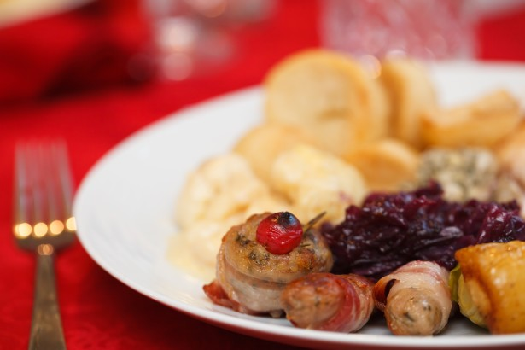

**Gamma Beta Christmas Brunch**

**Saturday, December 1, 2018**

**9:00 AM**



Warehouse Coffee Shop

315 Main Street West

Hartselle, AL 35640

Devotion: Debby Crowell

Business:

* Collect gifts for nursing home residents
* Draw for new teacher recruitment gift cards

Program:

* Christmas Brunch

Hostesses: Debby Crowell (chair), Wanda Duncan, Bonnie Black, Corkey Vann, Beth Milner, Joni Bair, Dawn Carroll, Jennie Roberts

**All members will be contacted by one of the hostesses to bring a brunch food to share.**



**2018-2019 Meeting Dates**

* February 7 – 4:30 PM at Excel Center, Austin Jr. High School, Decatur
* February 22-24 – Alabama State Convention, Embassy Suites, Huntsville
* February 24 – Ceremony of Remembrance at the State Convention. Faye Walker will be remembered during this ceremony.
* March 7 – 4:30 PM at OH! Bryan’s Family Steak House, Hartselle
* April 4 – 4:00 PM at Morgan County Board of Education, Priceville (Joint meeting with Mu)