Gamma Beta Newsletter
The Delta Kappa Gamma Society International
December, 2019
November Meeting Highlights

Gamma Beta met on November 2nd at Cook Museum in downtown Decatur for a tour. The natural science museum opened this past summer. It has many exhibits including caves, the ocean, forests, and of course BUGS! All the exhibits had hands-on activities for both children and adults. We finished this event with Carolyn Ellinger’s devotion and lunch at Cook’s on-site restaurant, Nature’s Table.

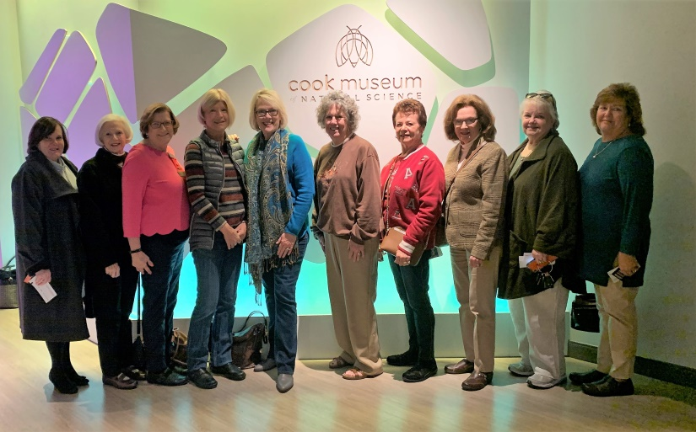

Officers Beth, Valerie, Dottie, and Lane enjoying the Salad Supper

Alabama State
PURPOSE:
To unite women educators of the world in a genuine spiritual fellowship: Delta Kappa Gamma members expand their friendships and increase their appreciation of women educators at home and abroad through travel, participation in international organizations, chapter meetings, conferences, workshops and conventions. Seminars, travel and study experiences, projects and programs are additional means of implementing this Purpose. World Fellowship grants provide opportunities for extended communication and understanding. A gift from the Emergency Fund to a member who suffers extensive loss from floods, tornadoes, hurricanes and similar disasters is a manifestation of spiritual fellowship.

Gamma Beta Website

Send photos to her at dmcrow56@gmail.com.
http://gammabetachapter.weebly.com/

December
15th Nickie Taylor
22nd Marthelle Stover

January
2nd Bonnie Black

December Meeting
December 7, 2019
9:00 AM

Pointe Mallard Estates Clubhouse
2901 Point Mallard Dr.
Decatur, AL

Devotion: Karen Parmer

Business:
- Draw names for supporting Early Career Educators Grant
- Collect gifts for nursing home residents
Program:
- Christmas Brunch
Hostesses: Debby Crowell chair, Jennie Roberts, Bonnie Black, Brenda Berryman, Beth Milner, Nickie Taylor, Dottie Donahue

REMINDERS:
- Members have been contacted by one of the hostesses to bring a brunch item to share.
- Bring a wrapped gift for a nursing home resident. Label your gift for a male, female, or either.

2019-2020 Chapter Meetings and Important Dates

- December 7, 2019 (Saturday), 9:00 AM – Christmas Brunch, Pte. Mallard Estates Clubhouse, Decatur
- February 6, 2020, 4:30 PM – Stone River United Methodist Church, Decatur
- February 29, 2020 – Alabama State Leadership Day, Delraida Church of Christ, Montgomery
- March 5, 2020, 4:30 PM – JW Steakhouse, Priceville
- April 9, 2020, 4:00 PM – Joint meeting with Mu Chapter – Morgan County Board of Education, Room A
- June 5, 2020 – One Day Workshop (replaced District Meetings), Delraida Church of Christ, Montgomery
- July 7-11, 2020 – International Convention, Philadelphia, PA

Looking Ahead

We will not meet during the month of January. Our next meeting will be February 6, 2020 at The Church at Stone River on Danville Rd. in Decatur beginning at 4:30 PM. Charity Wright will be joining us to instruct us on card making.

Make plans to attend Alabama State’s Leadership Day on February 29, 2020 at Delraida Church of Christ in Montgomery.

