**Gamma Beta Newsletter**

The Delta Kappa Gamma Society International

December 2021

**November Meeting Highlights**

Members present during the November meeting at West Hartselle Baptist Church were Lane Hampton, Sherri Peck, Jeanne Ellen Stroh, Nickie Taylor, Beth Milner, Ginger Richey, Karen Parmer, Corkey Vann, Valerie Powell, Brenda Berryman, Debby Crowell, Jennie Roberts, and Carolyn Ellinger.

Gamma Beta President Jeanne Ellen Stroh presides over the business meeting

Carolyn Ellinger delivers a meaningful devotion

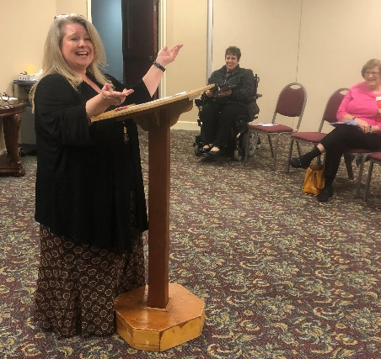

AAA Travel Agent Shawn Guthrie informs members of travel issues during the pandemic and popular travel destinations

Members look over travel brochures while listening to Shawn

Looks like Karen, Carolyn, and Corkey are ready to pack their bags

**Gamma Beta Website**

Send photos and information to Debby at dmcrow56@gmail.com.

<http://gammabetachapter.weebly.com/>

**Alabama State**

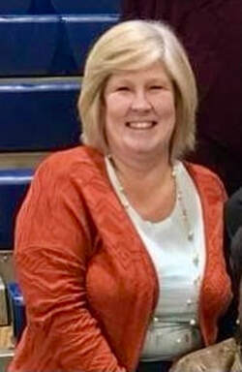

**ALABAMA STATE IS TURNING 90 DECEMBER 19TH! THINK OF WAYS TO CELEBRATE! President Penny asks that all members wear their pins that day and share pictures with Alabama State.**



November

27th Carolyn Ellinger

December

15th Nickie Taylor

22nd Marthelle Stover

January

2nd Bonnnie Black

February

1st Beth Weinbaum

13th Jo Ann Sneed

**December Meeting**

**December 4, 2021**

**9:00 AM**

**Saturday**

Home of Debby Crowell (Pointe Mallard Estates)

2406 Huntington Lane SE

Decatur, AL 35601

Devotion: Karen Parmer

Business:

* Collect gifts to take to River City Assisted Living
* Draw names for Supporting Early Career Educators Grant

Program:

* Christmas Brunch

Hostesses: Debby Crowell chair, Wanda Duncan, Debbie Ferguson, Nicki Taylor, Dottie Donahue, Corkey Vann

Directions from Hwy. 31 (6th Avenue) traveling north on 31:

* Turn left on 11th Street
* Travel about 2 miles all the way to the end of 11th. You will go past 3 traffic lights then will turn left on Regency Blvd. at the 2nd stop sign (11th ends here).
* Turn left at the first street, Surrey.
* Turn left at the stop sign on Brandywine.
* Turn right on Huntington Ln. (first street on right).
* 2406 is the 4th house on the right. It is a two-story charcoal gray home with black shutters and white garage doors.

**REMINDERS:**

* All members are asked to bring a brunch item to share.
* All assisted living gifts should be placed in gift bags and labeled for either female, male, or either.



**2021-2022 Chapter Meetings and Important Dates**

* December 4, 2021 – Gamma Beta Chapter Meeting at Debby Crowell’s Home – 9:00 AM - Christmas Brunch
* December 19, 2021 – Alabama State’s 90th birthday
* February 3, 2022 – Gamma Beta Chapter Meeting at West Hartselle Baptist Church – 4:30 PM - CPR Demonstration
* February 19, 2022 – Leadership Day at Delraida Church of Christ, Montgomery
* March 3, 2022 – Gamma Beta Chapter Meeting at Keramos Ceramics – 4:30 PM
* April 7, 2022 – Gamma Beta Meeting at West Hartselle Baptist Church – 4:30 PM – Founders Day Celebration with Mu Chapter – Penny Christian, Alabama State President
* June 3, 2022 – Officer Training Day for all new chapter officers at Delraida Church of Christ, Montgomery