Gamma Beta Newsletter
The Delta Kappa Gamma Society International
March, 2019

February Meeting Highlights

Our Chapter met at Decatur City School’s Excel Center on the campus of Austin Junior High School. Tammie Clark instructed the group on printmaking designs. Some of our sisters made bookmarks and others made cards. A good time was had by all.

The amazing artwork done by Beth Milner.

Alabama State News

The Alabama State convention was held last weekend, February 22nd – 24th, at the Embassy Suites in Huntsville. Your Gamma Beta sisters Brenda Berryman, Debby Crowell, Dottie Donahue, Beth Milner, and Valerie Powell represented our chapter at the convention. All attended meetings, wonderful workshops, and delicious meals and ceremonies. On Sunday morning during the Ceremony of Remembrance Faye Walker and Ann Henderson were remembered. The slate of officers for Alabama State was announced and voted on. Our 2019-2021 state officers are:

President: Teresa Noell
First Vice President: Penny Christian
Second Vice President: Ann Jones
Recording Secretary: Marion Hodges
Corresponding Secretary: Dianne Huey

In State business, the membership voted to have the positions of webmaster and editor combined to make one position. Also, the webmaster will receive a portion of State allocated money for travel to conventions and meetings.

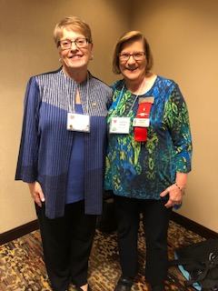
Valerie with International DKG President Cathy Daugherty

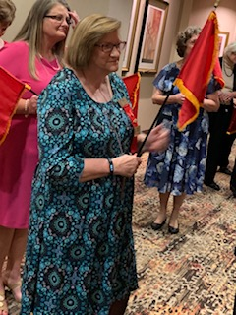
Gamma Beta President Valerie Powell carries our flag.

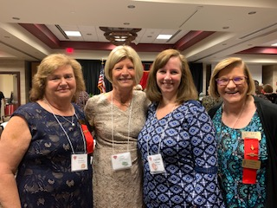
Gamma Beta sisters Brenda Berryman, Debby Crowell, Beth Milner, and Valerie Powell at Presidents’ and Founders’ Banquet. (missing Dottie Donahue)

Gamma Beta Website

Send photos and news to our web master, Debby Crowell. Email her at dmcrow56@gmail.com.
http://gammabetachapter.weebly.com/

March
7th Valerie Powell
14th Jeanne Ellen Stroh
26th Karen Parmer

April
1st Jennie Roberts
21st Ginger Richey

March Meeting
March 7,2019
4:30 PM
OH! Bryan’s Family Steak House
727 Main Street W.
Hartselle, AL 35640

Devotion: Jeanne Ellen Stroh

Business:
- NO BUSINESS MEETING

Program:
- Easter Craft
- Brainstorm Session – Suggestions for future meetings.

2018-2019 Meeting Dates

- April 4 – 4:00 PM at Walter Jackson Elementary School, Decatur (Joint meeting with Mu) – Donna Butler, 2017-2019, Alabama State President will be our speaker.

