Gamma Beta Newsletter
The Delta Kappa Gamma Society International
January 2022
Member News
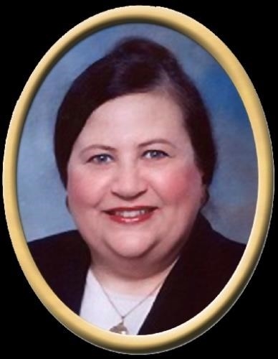

Nancy L. Worley, Alabama's Secretary of State from 2003 to 2007, died peacefully among family and friends in a Montgomery hospital on December 29, 2021. Worley, of New Hope and Montgomery was predeceased by her partner of 49 years, Wade Lipscomb, Jr. and her parents Leonard "Si" and Lillian Smith Worley of New Hope. She is survived by uncles, cousins and a multitude of friends. Worley's tenure as Secretary of State included substantial reforms, including longer and uniform polling hours, voter identification, and automatic recounts in close races. After graduation from New Hope High School, where she was in the top ten of her class and was Homecoming Queen and Miss New Hope H. S., Nancy attended the University of Montevallo earning a B.A. degree with highest honors in 1973 and was named Alumnus of the Year in 1990. She continued her education at Jacksonville State University, where she earned her M.A. degree in 1975. Worley spent twenty-five years at Decatur High School where she taught Latin, English, and sponsored cheerleaders and student clubs. She was a part-time instructor for John C. Calhoun and Northeast State Community Colleges. Her former students attribute her strict, demanding, yet highly interesting classes as responsible for much of their success in later life. She received various teaching awards including twice-named Teacher of the Year; nominated to the Teacher Hall of Fame; and honored by the Alabama Jaycees as Alabama's Outstanding Young Educator. She was included in Good Housekeeping's "100 Young Women of Promise" and was named by The Decatur Daily as one of the "Twenty Leaders of Decatur." She was twice elected as President of the Alabama Education Association serving from 1983-84 and 1995-97. Nancy was a tireless spokesperson for education believing that public education "is the highest yielding, lowest-risk investment that we can make in our nation's future." In addition to serving as AEA President, she was President of the Decatur Education Association, the Alabama Foreign Language Teachers Association, Opportunity Toastmistress Club and the Alabama Classical Association. She served twice as President of the Association of Classroom Teachers, twice as State President of the American Association of University Women (AAUW) and was a member of Delta Kappa Gamma International Society of Women Educators. In retirement, Nancy served a term on the Alabama Education Retirees Association Board, continued to serve on association committees and as a delegate to both the Alabama Education Association Delegate Assembly and the National Education Association Representative Assembly. She was recognized with the Educator Award by the Alabama Senior Citizens Hall of Fame. Worley was Chairman of the Alabama Democratic Party. She was a member of the State Democratic Executive Committee for 5 terms and was elected delegate to the Democratic National Convention several times. She served on the Governor's Task Force on Welfare Reform, the Governor's Task Force on Education Reform, the Lt. Governor's Legislative Council, and numerous other state and national policy committees. As a member of the Tuition Eligibility Board, she worked to provide scholarships to the families of deceased police officers and firefighters. Nancy lobbied with the AARP Capital City Task Force on Senior Citizen issues, among many other activities. Nancy loved books, theatre, concerts, good speakers, travel, lunch with friends, and collecting antiques. She credited her reading of the Bible and numerous teachers, church, community, civic and political leaders with teaching her the value of hard work, the importance of education, the need for involvement in community and causes, and respect for the dignity of all persons. She dedicated her life to making a difference and to serving others. She was committed to fairness, justice, and equality for everyone.

December Meeting Highlights
Members present during the December meeting at Debby Crowell’s home were Lane Hampton, Sherri Peck, Jeanne Ellen Stroh, Nickie Taylor, Beth Milner, Wanda Duncan, Karen Parmer, Debbie Wiggins, Valerie Powell, Brenda Berryman, Debby Crowell, Jennie Roberts, Dottie Donahue, Jo Ann Sneed, Beth Weinbaum, Bonnie Black, and Wendy Duffey. The members enjoyed a delicious brunch while visiting with one another.

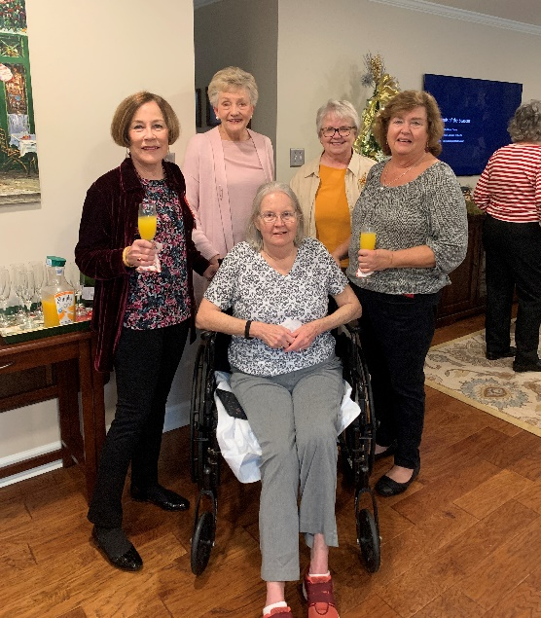
Members Wanda Duncan, Jo Ann Sneed, Debbie Wiggins, Bonnie Black, and Brenda Berryman are enjoying gathering.
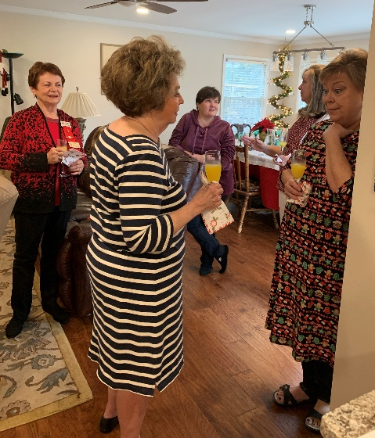
Nickie Taylor, Beth Weinbaum, Jennie Roberts, Beth Milner, and Jeanne Ellen Stroh converse with one another.
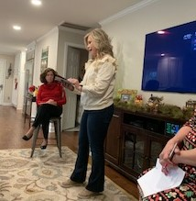
Karen Parmer reads “A Walk One Winter Night”. The story reminded all of us of the true meaning of Christmas.
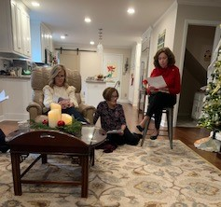
Karen and Wanda listen as Dottie gives the treasurer’s report.

During the business meeting three first year teachers were randomly drawn to receive $50 Staples gift cards to help with their classroom supplies. Winners were:
Hartselle City - Bree Drake
Morgan County - Anna Hayden
Decatur City - Brittany Tanner

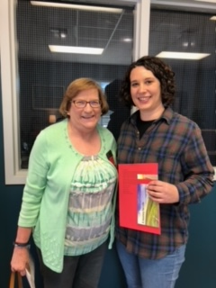
Valerie Powell delivers the Staples’ Card to Anna Hayden at Eva Elementary

A tentative plan for fundraising was discussed. President Jeanne Ellen will form a committee to finalize this plan.

Members brought gifts to be delivered to River City nursing home in Decatur. The activity director was VERY appreciative of the gifts!

Gamma Beta Website
Send photos and information to Debby at dmcrow56@gmail.com.
http://gammabetachapter.weebly.com/

Alabama State
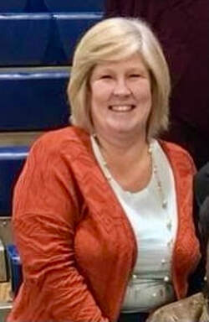
From Alabama State President Penny Christian

Leadership Day is fast approaching. Candace Martin, our SE Regional Director, will be joining us that day. Candace will be bringing updated news from International and information about amendments we will be discussing and voting on in New Orleans at our International Convention. Mrs. Velma Essex, Gamma Phi, will lead us in a DKG sing-along. Bring your best singing voice and join us.

Save the dates: Scholarship applications are due February 1st to Dr. Alexandra Conniff. Applications can be found on the website. Achievement award applications are due May 1st to Allison Hill. Achievement award applications can also be found on the website.

February
1st Beth Weinbaum
13th Jo Ann Sneed
March
7th Valerie Powell
14th Jeanne Ellen Stroh
26th Karen Parmer

February Meeting
February 3, 2022
4:30 PM
Thursday
West Hartselle Baptist Church
1640 Main St.W.
Hartselle, AL 35640

Devotion: Wanda Duncan
Business:
- Collect for Eagles Wings, Inc. our State DKG Project
Program:
- Heart health and CPR demonstration
Hostesses: Jeanne Ellen Stroh chair, Jennie Roberts, Bonnie Black, Brenda Berryman, Beth Milner, Wendy Duffey

REMINDERS:
- COLLECTION FOR EAGLES WINGS, INC.

2021-2022 Chapter Meetings and Important Dates

- February 1, 2022 – Scholarship applications due to Alexandra Conniff
- February 3, 2022 – Gamma Beta Chapter Meeting at West Hartselle Baptist Church – 4:30 PM - CPR Demonstration
- February 19, 2022 – Leadership Day at Delraida Church of Christ, Montgomery
- March 3, 2022 – Gamma Beta Chapter Meeting at Keramos Ceramics – 4:30 PM
- April 7, 2022 – Gamma Beta Meeting at West Hartselle Baptist Church – 4:30 PM – Founders Day Celebration with Mu Chapter – Penny Christian, Alabama State President
- May 1, 2022 – Achievement Award applications due to Allison Hill
- June 3, 2022 – Officer Training Day for all new chapter officers at Delraida Church of Christ, Montgomery
- July 12 – 16, 2022 – International Convention in New Orleans

