Gamma Beta Newsletter
The Delta Kappa Gamma Society International
February 2023

February Meeting Highlights

Wendy Lang, UniServ Director for District 5 with the Alabama Education Association (AEA), conducts a presentation on team-building.

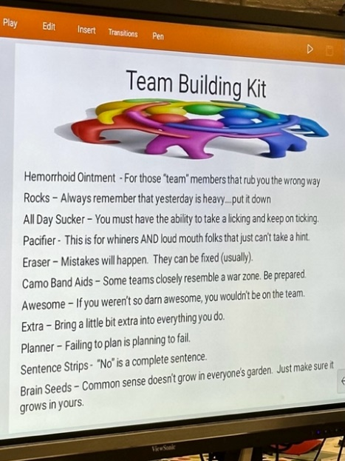
- Members present were: Lane Hampton, Beth Milner, Wanda Duncan, Jennie Roberts, Dottie Donahue, Jeanne Ellen Stroh, Bonnie Black, Wendy Duffey, Nickie Taylor, Carolyn Ellinger, and Debby Crowell
- Devotion – Wanda Duncan
- Quote presented from Wendy Lang: “If you want God to open and close doors, you’d best get your hand off the doorknob.”
- State Convention in Tuscaloosa March 3 – 5, 2023
- The meeting concluded with singing the Delta Kappa Gamma song

Members enjoying Valentine snacks while listening to Wendy Lang.
Gamma Beta Website
Send photos and information to Debby at dmcrow56@gmail.com.
http://gammabetachapter.weebly.com/
Alabama State
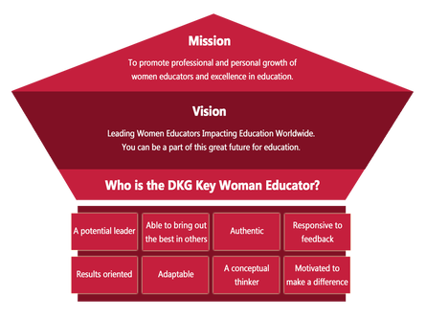
Proposed Slate of Elected Officers for 2023-2025
President – Ann Jones
First Vice President – Dawn Pettit
Second Vice President – Gennice Burch
Recording Secretary – Allison Hill
Corresponding Secretary – Amy Stills
Nominations Committee, District I – Mary Beth Henry
Personnel Committee, District II – Marion Hodges
Nominations Committee, District III – Kerry Montgomery
Personnel Committee, District IV – Dianne Huey
Nominations Committee, District V – Wendy Stephens
Personnel Committee, District VI – Dianne Casolaro
Nominations Committee, District VII – Patsy Powell
Alabama State Convention – Hotel Capstone Tuscaloosa March 3rd – 5th.
Ceremony of Remembrance, Sunday, March 5, 2023, 8:15 – 9:45 AM. Gamma Beta members remembered are Catherine Sims, Nancy Worley, Marthelle Stover, and Debbie Wiggins.
March
7th Valerie Powell
14th Jeanne Ellen Stroh
26th Karen Parmer
April
1st Jennie Roberts
21st Ginger Richey

March Meeting

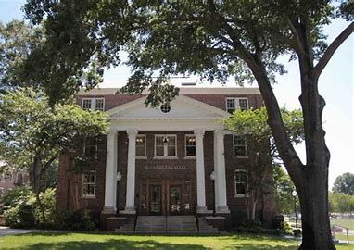
March 2, 2023
4:30 PM
Thursday
Athens State University
McCandless Hall
300 N. Beaty Street
Athens, AL

Devotion: Karen Parmer
Business:
- No Business Meeting
Program:
- Tour of Athens State University

No Refreshments served during this meeting. Rumor has it that a stop at Buc-ees may occur after the meeting.

SPECIAL INSTRUCTIONS:
- Look for an email from Dottie Donahue for special instructions.

2022-2023 Chapter Meetings and Important Dates

- March 2, 2023 – Gamma Beta Meeting – Athens State University
- March 3-5, 2023 – Alabama DKG State Convention – Tuscaloosa - MAKE PLANS TO ATTEND
- April 6, 2023 – Joint meeting with Mu Chapter – West Hartselle Baptist Church

