Gamma Beta Newsletter
The Delta Kappa Gamma Society International
January, 2019

Member News

Keep Lane Hampton in your thoughts and prayers as she recovers from recent knee surgery. Feel better soon, Lane!

December Meeting Highlights

Our December meeting/Christmas Brunch was held at Warehouse Coffee Shop on Main Street in Hartselle. The facility provided a private room for us which was tastefully decorated for the holidays. The staff was very accommodating to our needs. I must say that they make a VERY delicious hot chocolate. Members all brought brunch foods to share. No one went away hungry!!

Valerie brought some Gamma Beta memorabilia that Faye had saved. It was fun looking through them and seeing who all had been members at one time. We also collected nursing home gifts that Valerie then took to Summerford Nursing Home in Falkville. They were very appreciative!

Gifts to take into Summerford Nursing Home

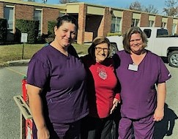
The Summerford Staff were very appreciative of the gifts!

Three lucky new teachers were randomly picked to receive $50 gift cards for Staples. The teachers selected were:
- Emily Bounds – Cedar Ridge Middle School
- Monica Maples – Cotaco Junior High
- Tristan Harmon – Hartselle Intermediate School

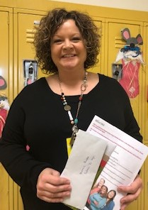
Monica Maples, one of our gift card recipients.
Emily Bounds, choral teacher/director at Cedar Ridge Middle School – Gift card recipient

Alabama State News

- Alabama State Convention will be held February 22-24, 2019 in Huntsville at the Embassy Suites.
- Deadline to make hotel reservations at the Embassy is January 21, 2019.
- Deadline to register for the convention is February 1, 2019. You can print off the registration form on the Alabama State website or off of the email that Valerie sent out.

Gamma Beta Website

Send photos and news to our web master, Debby Crowell. Email her at dmcrow56@gmail.com.
http://gammabetachapter.weebly.com/

January
2nd Bonnie Black

February
1st Beth Weinbaum
13th Jo Ann Snead

March
7th Valerie Powell
14th Jeanne Ellen Stroh
26th Karen Parmer

February Meeting
February 7, 2019
4:30 PM
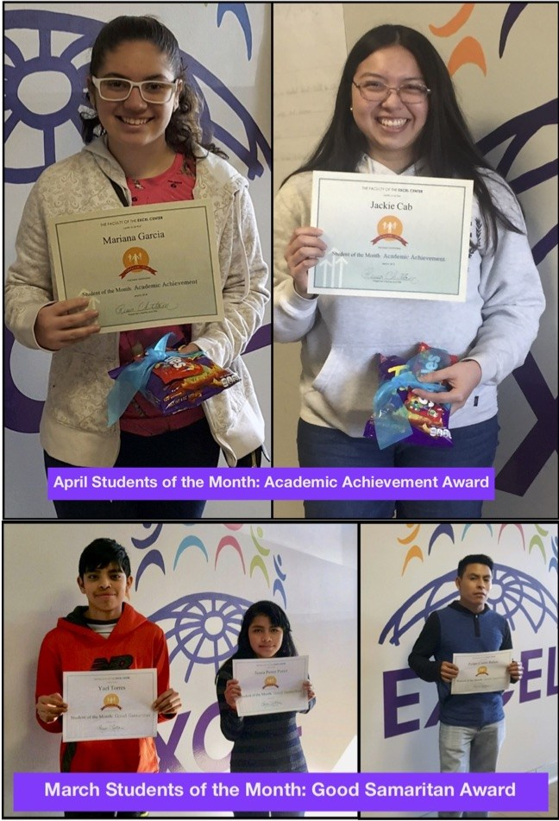
Excel Center
Austin Junior High
1625 Danville Road SW
Decatur, AL 35601

Devotion: Valerie Powell

Business:
- Alabama State Convention

Program:
- Printmaking – Tammie Clark
- Fellowship

Hostesses: Beth Milner (chair), Jeanne Ellen Stroh, Beth Weinbaum

Enter the Excel Center at the first entrance off of Westmeade by the Excel sign. Joni Bair will be letting you in. If you get there late, call Joni 256-227-9462.

2018-2019 Meeting Dates

- February 22-24 – Alabama State Convention, Embassy Suites, Huntsville
- February 24 – Ceremony of Remembrance at the State Convention. Faye Walker will be remembered during this ceremony.
- March 7 – 4:30 PM at OH! Bryan’s Family Steak House, Hartselle
- April 4 – 4:00 PM at Morgan County Board of Education, Priceville (Joint meeting with Mu)

