Gamma Beta Newsletter
The Delta Kappa Gamma Society International
January, 2020

December Meeting Highlights

Gamma Beta met on December 7, 2019 at Pointe Mallard Clubhouse for our Christmas Brunch. During the business meeting the members voted to have silent auction at the April meeting with Mu Chapter. Suggested items for this fund-raiser are a new or used item, gift card, jewelry, homemade food item or craft, solicited service from a local business?? We have not had a fundraiser for quite a few years so let’s make this a good one.

Three new teachers were randomly selected to receive a $50 Staples gift card for our Supporting Early Educator’s Project. Winners this year are:

- Jennifer Lee – Austin High School, Decatur City Schools
- Erica Blackstock – Priceville High School, Morgan County Schools
- Annette Guice – FE Burleson Elementary, Hartselle City Schools

We also collected gifts for nursing home residents. This year the gifts were taken to River City Care and Rehab Center in Decatur. The gifts were MUCH appreciated!

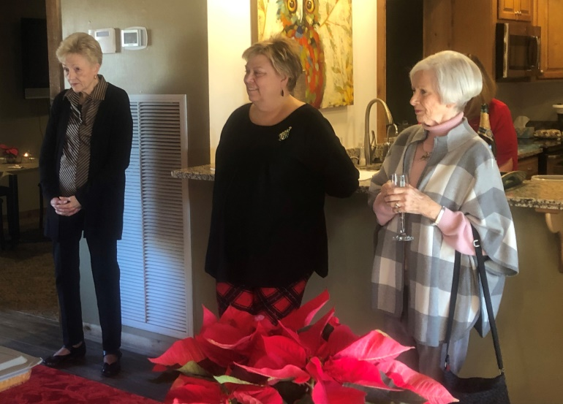
Jo Ann, Jeanne Ellen, and Caroline listen to Karen Parmer’s Devotion.

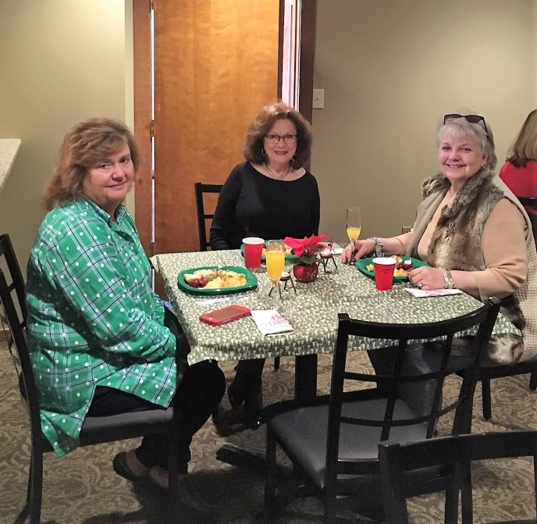
Brenda, Dottie, and Bonnie relish the delicious brunch.

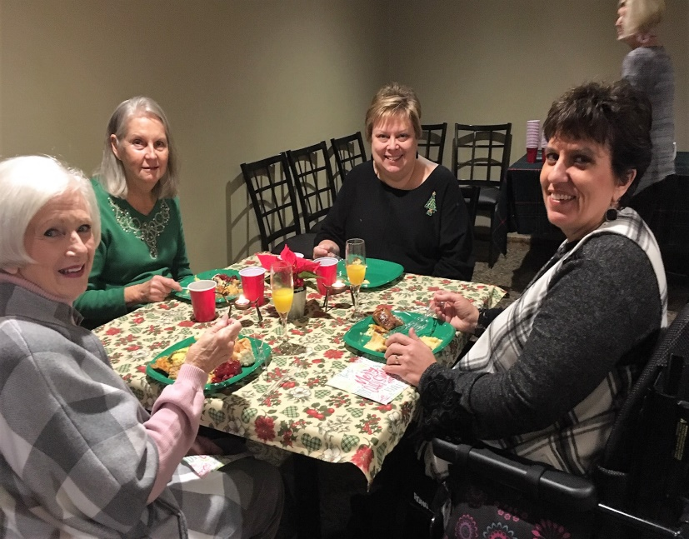
Jeanne Ellen, Ginger, and Caroline enjoying their food with prospective new member Debbie Wiggins.

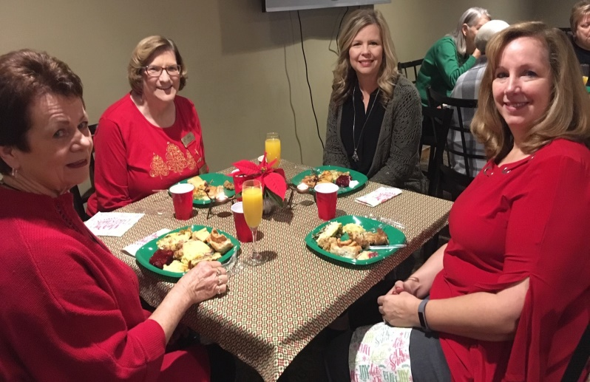
Nickie, Valerie, Karen, and Elizabeth love having time to converse with one another.
Nursing home gifts under the tree.

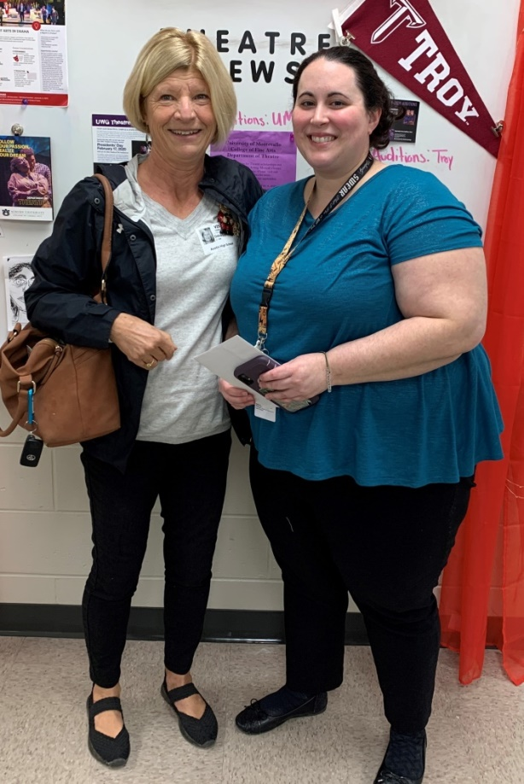
Debby delivers Early Educator gift card to ex-student, Jennifer Lee, Drama Teacher at Austin High School.
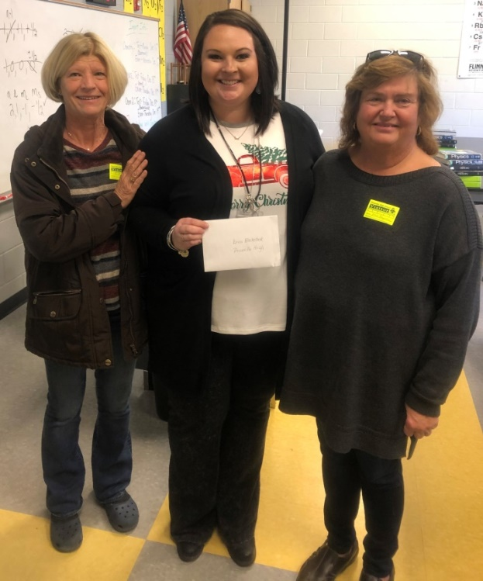
Priceville’s new math teacher, Erica Blackstock, is very appreciative of the Staple’s Gift Card.

Alabama State
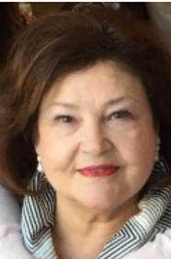
A Message from Teresa Noell,
​2019-2021 Alabama State Organization President
Happy New Year to each of you! It is mind-boggling to me that not only have we welcomed a new year but also a new decade in this millennium. The adage “Time marches on” takes on greater meaning as I grow older. As I think about my blessings—and I have so many--I count each of you among them.
As we enter 2020 your chapters and Alabama State are busy with the business, meetings, events, fun, and fellowship of Delta Kappa Gamma. I am very thankful to be a part of such a group of “key women educators.” I enjoyed each chapter visit I made last fall, and I look forward to many visits this year.
We have so many opportunities this year from the local to the state to the international levels. February 29th is Alabama State's second biennial Leadership Day. We will be at Dalraida Church of Christ with registration beginning at 9:30 and training 10:00-3:00. This training will be led by Southeastern Director Elaine Warwick. The day is designed to provide us with ideas and skills that we can use in any leadership role within or outside Delta Kappa Gamma. For those who wish Continuing Education Units, they will be available to you. Please see the registration form in this newsletter and on our website.
You will see in this newsletter Executive Director Libby Watson's very entertaining article about International Convention in Philadelphia July 7-11. Put this event on your calendar and watch for more details to come!
We know that in any group of which we are a part we and the group benefit more based on our participation. In her Keynote Address to the participants at the 2019 Arts and Humanities International Conference in Asheville, North Carolina, in June 2019, International President Cathy P. Daugherty discussed three goals that will assist chapters, states, and international to regain membership (the lifeblood of all organizations) and enthusiasm. I would like to state these in the briefest of ways in order to whet your appetite to read her address in its entirety in the most recent COLLEGIAL EXCHANGE. Why? I believe that our chapters and state can find ideas that will be beneficial to our membership—both present and future. They are 1. Commitment to the mission and Purposes of the Society, 2. Professionalism in our programs at all levels, and 3. Recognition of Members. Please read the entire article to find what may benefit your local chapter. Please let me hear from you about your thoughts and ideas.
Our newsletter now has the capacity for more news, pictures, and articles. Webmaster Amy Crew needs your help in submitting these. Per past practice, please submit these to me, and I will forward them to Amy. In this edition you will enjoy items submitted by state officers and several state committee chairs. These are to better equip us as members and leaders as we “Continue the Journey: Be the Inspiration”!
Sister to Sister,
Teresa
(From Alabama State Webpage)

Gamma Beta Website
Send photos to Debby at dmcrow56@gmail.com.
http://gammabetachapter.weebly.com/

January
2nd Bonnie Black
February
1st Beth Weinbaum
13th Jo Ann Sneed

February Meeting
February 6, 2020
4:30 PM
JW Steakhouse
45 Marco Drive
Decatur, AL
Devotion: Jeanne Ellen Stroh

Program:
- Report from Grant winners for Supporting Early Career Educators

NOTE: Our card-making program facilitator, Charity Wright is unable to make it to our meeting in February so our March meeting at JW Steakhouse will be in February and we will meet at Stone River United Methodist Church in March.

2019-2020 Chapter Meetings and Important Dates
- February 1, 2020 Scholarship application deadline (Alabama State and International)
- February 1, 2020 Deadline for Cornetet Professional Development application
- February 6, 2020, 4:30 PM – JW Steakhouse, Priceville
- February 29, 2020 – Alabama State Leadership Day, Delraida Church of Christ, Montgomery
- March 5, 2020, 4:30 PM –Stone River United Methodist Church, Decatur
- April 9, 2020, 4:00 PM – Joint meeting with Mu Chapter – Morgan County Board of Education, Room A- GAMMA BETA Silent Auction Fundraiser
- June 5, 2020 – One Day Workshop (replaced District Meetings), Delraida Church of Christ, Montgomery
- July 7-11, 2020 – International Convention, Philadelphia, PA
Looking Ahead

Our next meeting will be March 5, 2020 at The Church at Stone River on Danville Rd. in Decatur beginning at 4:30 PM. Charity Wright will be joining us to instruct us on card making. Hostesses for this meeting are: Wanda Duncan (chair), Jeanne Ellen Stroh, Karen Parmer, Wendy Duffy, Beth Weinbaum, Corkey Vann, and Valerie Powell. Devotion for the March meeting will be Wanda Duncan.

Make plans to attend Alabama State’s Leadership Day on February 29, 2020 at Delraida Church of Christ in Montgomery.

