Gamma Beta Newsletter
The Delta Kappa Gamma Society International
January 2023
Member News
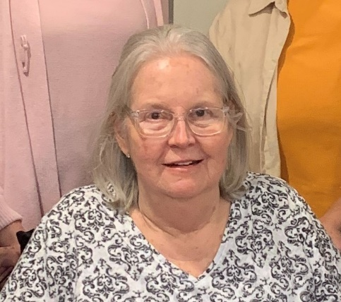
Deborah “Debbie” Webb Wiggins
Our sister, Debbie Wiggins, passed away on December 20, 2022 from Multiple Systems Atrophy (MSA). Debbie taught Spanish and English for more than 40 years mainly at Austin High School. She is survived by her three children, Webb, Wade, and Meredith Wiggins.

Nicholas Andrew Powell (Nic)

Please keep Valerie and Craig Powell along with their family in your thoughts and prayers after the death of their son Nic. Nic dies on Sunday, January 22, 2023, at UAB Hospital after a long battle with Kidney Disease. A funeral service for Nic will be Saturday, January 28, 2023 at 3:00 PM at Peck Funeral Home in Hartselle. Visitation will be from 1:00 – 3:00PM prior to the service. In lieu of Flowers, please consider donating in his honor to the Alabama Kidney Foundation.
https://www.networkforgood.org/donation/ExpressDonation.aspx?ORGID2=51-0189641&vlrStratCode=fyUod8CXrBCaRER4cf0Sf%2fFV3YiQAX%2fsVYHAGKJrjCqTs9FWFsxiAcdQ5mlrTzbg
December Meeting Highlights

Our resident artist, Bonnie Black, did the devotion and gave each of us a hand-painted Nativity.
- Members present were: Lane Hampton, Beth Milner, Corkey Vann, Brenda Berryman, Wanda Duncan, Jennie Roberts, Debbie Ferguson, Dottie Donahue, Jeanne Ellen Stroh, Bonnie Black, Beth Weinbaum, and Debby Crowell
- After Jeanne Ellen blessed the food we enjoyed a delicious brunch
- Devotion – Bonnie Black
- The strategic action plan was discussed
- Members collected money for our International World Fellowship fund and our Alabama State project, Eagles Wings, Inc.
- Three first year teachers were randomly drawn to receive Staples gift cards to help with their classroom purchases:
- Samantha Brantley – Decatur City Schools
- Dawn Zanda – Hartselle City Schools
- Leslee Hardman – Morgan County Schools
- Members brought gifts for nursing home residents. The gifts were taken to Falkville Healthcare Center
- The meeting concluded with singing the Delta Kappa Gamma song
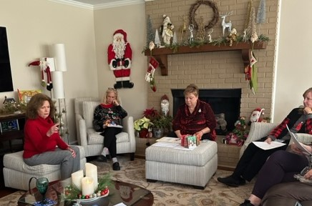
Jeanne Ellen conduct Gamma Beta’s business meeting while Dottie, Debbie, and Beth listen
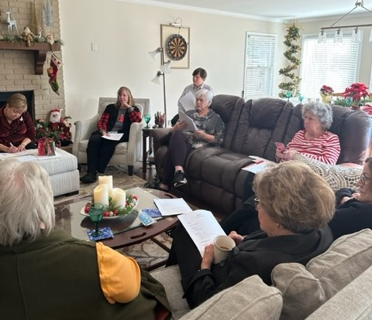
Lane takes notes while Beth, Jennie, and Corkey agree with our Strategic Action Plan

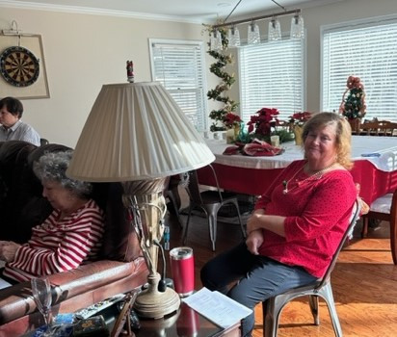
Brenda waits for the collection basket to be passed

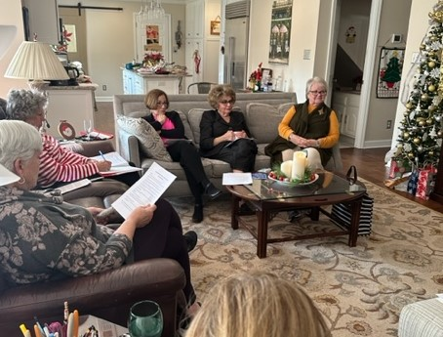
Wanda, Beth and Bonnie listen as the Early Career Educator gift card recipients are chosen
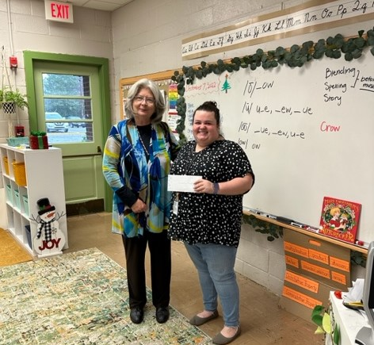
Samantha Brantley, 1st year 3rd grade teacher at Walter Jackson Elementary School, receives a Early Career Educator gift card with help from principal Angie Whittington

Gamma Beta Website
Send photos and information to Debby at dmcrow56@gmail.com.
http://gammabetachapter.weebly.com/

Alabama State
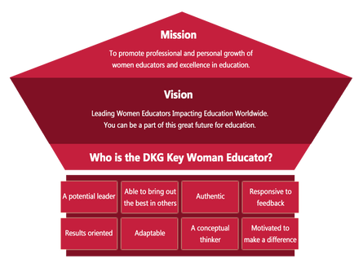
Proposed Slate of Elected Officers for 2023-2025
President – Ann Jones
First Vice President – Dawn Pettit
Second Vice President – Gennice Burch
Recording Secretary – Allison Hill
Corresponding Secretary – Amy Stills
Alabama State Convention – Hotel Capstone Tuscaloosa March 3rd – 5th. Registration form is on the Alabama State website.

February
1st Beth Weinbaum
13th Jo Ann Sneed
March
7th Valerie Powell
14th Jeanne Ellen Stroh
26th Karen Parmer
February Meeting

February 2, 2023
4:30 PM
Thursday
West Decatur Elementary School
708 Memorial Dr. SW
Decatur, AL 35601

Devotion: Wanda Duncan
Business:
- Collect for World Fellowship and Eagle’s Wings
Program:
- Team Building with Wendy Lang

Hostesses for this meeting: Beth Milner (chair), Bonnie Black, Brenda Berryman, Wendy Duffy, Valerie Powell

SPECIAL INSTRUCTIONS:
- Park in the back of the school.
- Enter doors by the cafeteria.
- If you are unable to get in, knock on the cafeteria windows or text someone.

2022-2023 Chapter Meetings and Important Dates

- February 1, 2023 – Deadline for Alabama State’s scholarship application submission
- February 2, 2023 – Deadline to reserve a room at Hotel Capstone, Tuscaloosa
- February 3, 2023 – Gamma Beta Meeting – West Decatur Elementary School – Team Building
- March 2, 2023 – Gamma Beta Meeting – Athens State University
- March 3-5, 2023 – Alabama DKG State Convention – Tuscaloosa - MAKE PLANS TO ATTEND
- April 6, 2023 – Joint meeting with Mu Chapter – West Hartselle Baptist Church

