Gamma Beta Newsletter
The Delta Kappa Gamma Society International
February, 2020

February Meeting Highlights

Gamma Beta had a dinner meeting at JW Steakhouse on February 6th. Beth Milner had a cute valentine craft ready for us to assemble. Dottie Donahue presented a pamphlet on Women’s Heart Health.

Though none of our Early-Career Educator gift card winners were able to attend the meeting Valerie Powell had feedback from Annette Guice - FE Burleson and Debby Crowell had feedback from Erica Blackstock – Priceville HS and Jennifer Lee – Austin HS. All ladies were very appreciative to receive the extra help.

Jeanne Ellen Stroh gave a report from the nominations committee. The proposed slate of officers for the 2020-2022 biennium is:
- President: Valerie Powell
- First Vice President: Beth Milner
- Recording Secretary: Lane Hampton
- Corresponding Secretary: Nickie Taylor
The election of the new officers will take place at the March meeting.

Valerie asked the By Laws committee to meet to update our chapter rules so they align with International rules. The updated by laws will be presented at the March meeting.

The view from Dottie’s kitchen window while the by-laws were being revised.

Alabama State
Leap Into Leadership
February 29, 2020
Delraida Church of Christ
Montgomery, AL

Gamma Beta Website
Send photos to Debby at dmcrow56@gmail.com.
http://gammabetachapter.weebly.com/

March
7th Valerie Powell
14th Jeanne Ellen Stroh
26th Karen Parmer

April
1st Jennie Roberts
21st Ginger Richey

March Meeting
March 5, 2020
4:30 PM
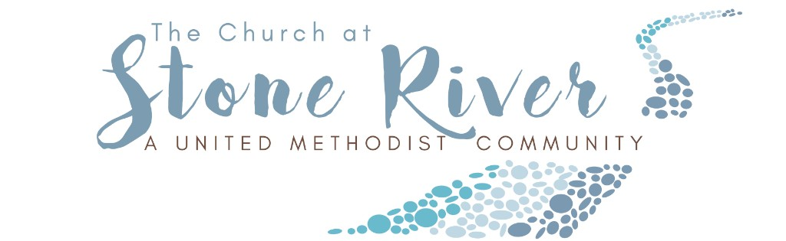
The Church at Stone River (A United Methodist Community)
3014 Danville Road SW
Decatur, AL 35603
Devotion: Wanda Duncan
Business:
- Officer Elections
- By-Laws
Program:
- Card-making – Charity Wright – Please bring $10 to cover the cost of supplies.

Hostesses: Wanda Duncan (chair), Jeanne Ellen Stroh, Karen Parmer, Wendy Duffey, Beth Weinbaum, Corkey Vann, Valerie Powell

NOTE: Please RSVP to Valerie, vlpowell213@att.net, so Charity Wright will know how many to prepare for.

2019-2020 Chapter Meetings and Important Dates

- March 5, 2020 – Chapter Meeting at Stone River – 4:30 PM
- April 9, 2020 – Joint Meeting with Mu Chapter at Morgan County BOE – 4:00 PM
- May 16, 2020 – Gamma Beta Induction of new members – Home of Sherri Peck
- June 5, 2020 – One Day Workshop (replaced District Meetings), Delraida Church of Christ, Montgomery
- July 7-11, 2020 – International Convention, Philadelphia, PA

