Gamma Beta Newsletter
The Delta Kappa Gamma Society International
March, 2021

Member News
Debbie Wiggins expressed thanks to our chapter for the Zaxby’s gift card. She said that Zaxby’s is a favorite of theirs.

February Meeting Highlights
Gamma Beta met at West Hartselle Baptist Church on February 4th at 4:30 PM. In attendance were:
Jeanne Ellen Stroh, Beth Milner, Valerie Powell, Caroline Ellinger, Debby Crowell, Sherri Peck, Lane Hampton, Karen Parmer, Jennie Roberts and Dottie Donahue.

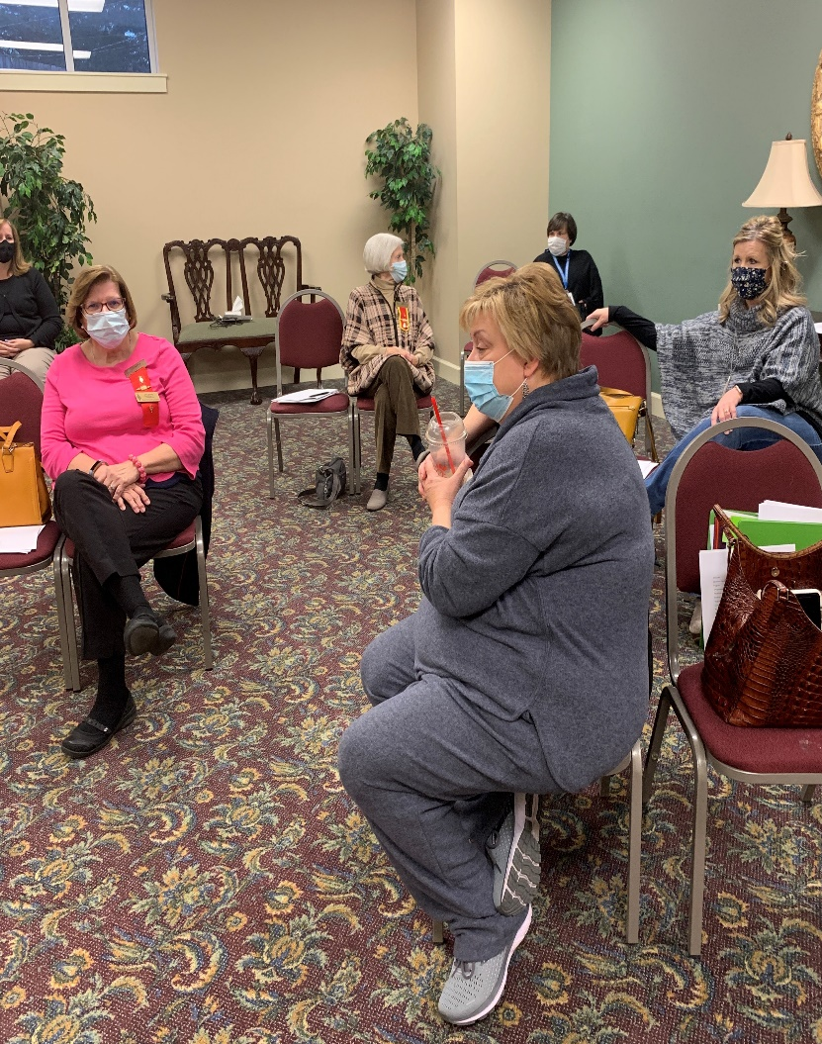
A few social minutes before beginning the meeting.

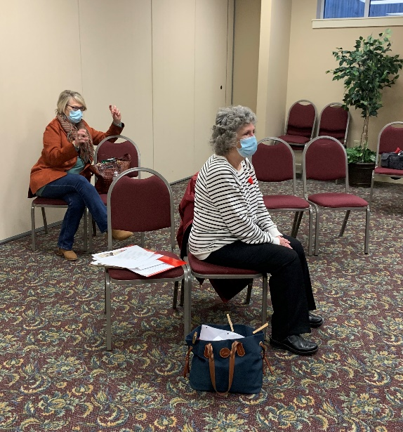
Sherri and Lane explain to the chapter that West Hartselle Baptist would not accept payment for the use of the building after our first meeting. Thank you!!
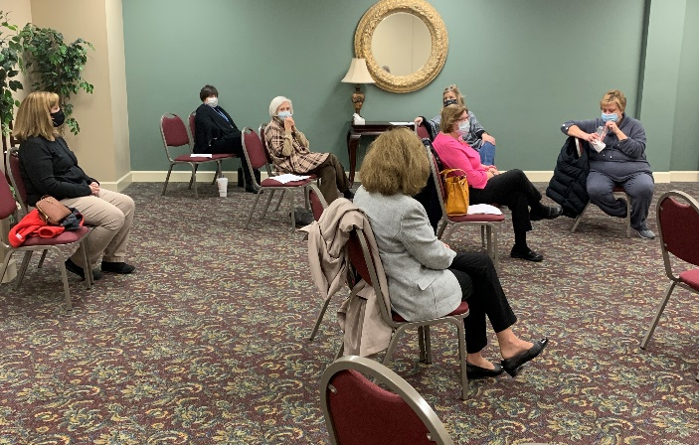

The program for our meeting was a CPR refresher. Unfortunately Kelli Morton was unable to attend due to having to work on scheduling vaccines for Hartselle City’s faculty and staff. Of course we all understood. Sign of our times!! Kelli would like to come to one of our meetings in 2022 to educate us on this important process.
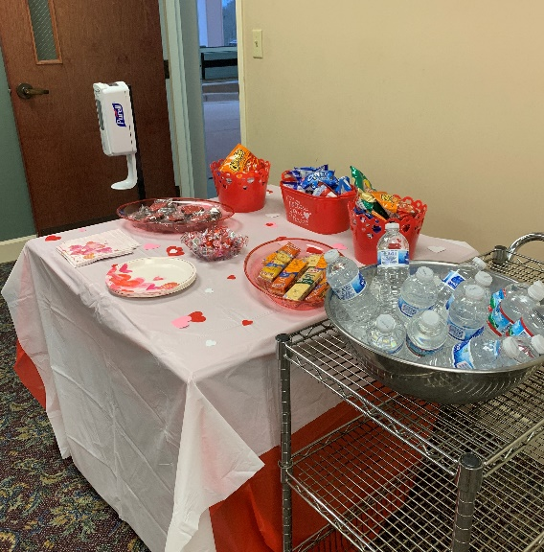
Yummy, safe snacks.
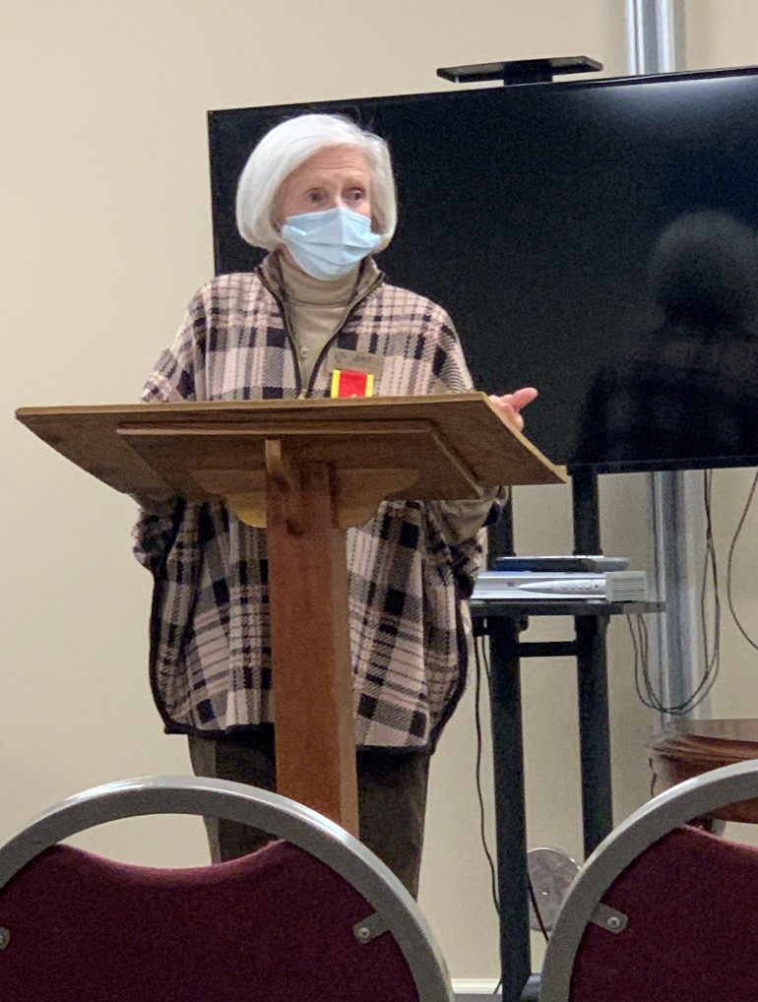
Carolyn Ellinger with our devotion
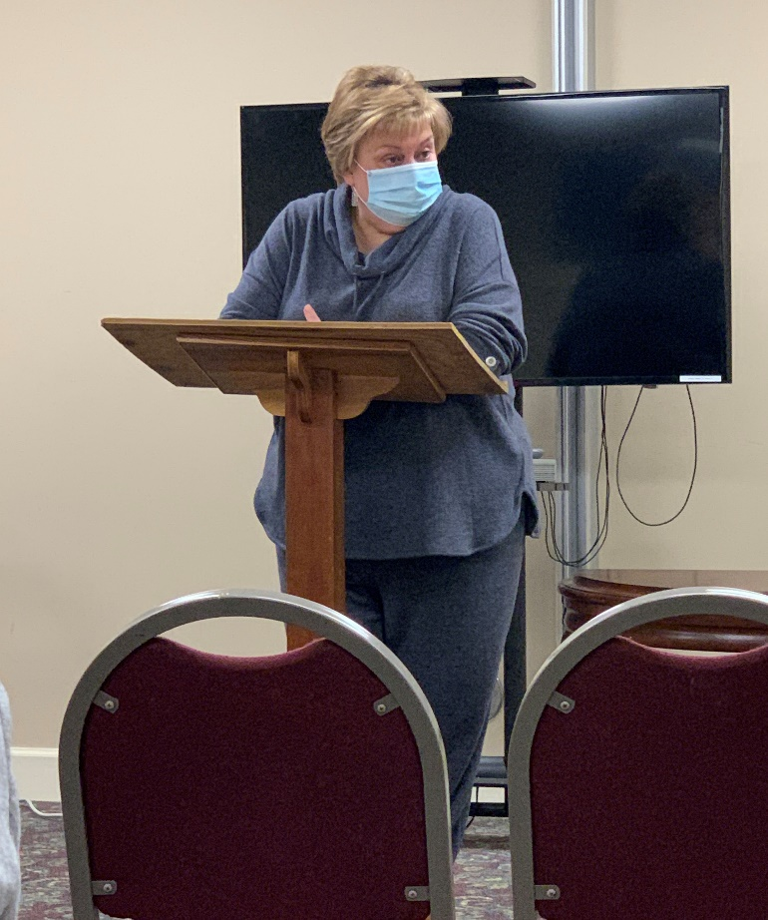
President Jeanne Ellen conducts the business meeting

Alabama State News
Alabama State President Teresa Noell

The application for the Alabama State Scholarship for 2021-2022 has been extended from February 1st to April 1st. If you are working on a graduate degree please consider applying for this nice scholarship. The application can be found on Alabama State’s website, http://alabamadkg.weebly.com.

The Alabama State Leadership Conference is tentatively set up for June 12 – 13 at Jacksonville State. If you have not attended a leadership conference this is an event you do not want to miss.

The proposed amendments to Alabama State’s By Laws have been sent out. Please read these over. They will be voted on at the State Convention May 22nd.
Gamma Beta Website
Send photos and information to Debby at dmcrow56@gmail.com.
http://gammabetachapter.weebly.com/

March
7th Valerie Powell
14th Jeanne Ellen Stroh
26th Karen Parmer

April
1st Jennie Roberts
21st Ginger Richey

March Meeting
March 4, 2021
4:30 PM
West Hartselle Baptist Church
1640 Main Street W.
Hartselle, AL 35640
Devotion: Karen Parmer
Business:
- Report from Grants to Early Educators Project
Program:
- Inspired Health – Jennifer Bell

Hostesses: Jeanne Ellen Stroh chair, Jennie Roberts, Bonnie Black, Brenda Berryman, Beth Milner

2021 Chapter Meetings and Important Dates

- March 4, 2021 – Gamma Beta Chapter Meeting at West Hartselle Baptist Church – 4:30 PM
- April 1, 2021 – Deadline for submitting application for the Alabama State Scholarship
- April 8, 2021 – Gamma Beta Chapter Meeting at West Hartselle Baptist Church – 4:30 PM
- May 22nd - Alabama State One Day Convention – Embassy Suites, Montgomery
- June 12-13, 2021 – Leadership Weekend at Jacksonville State University

