Gamma Beta Newsletter
The Delta Kappa Gamma Society International
March 2022
Member News
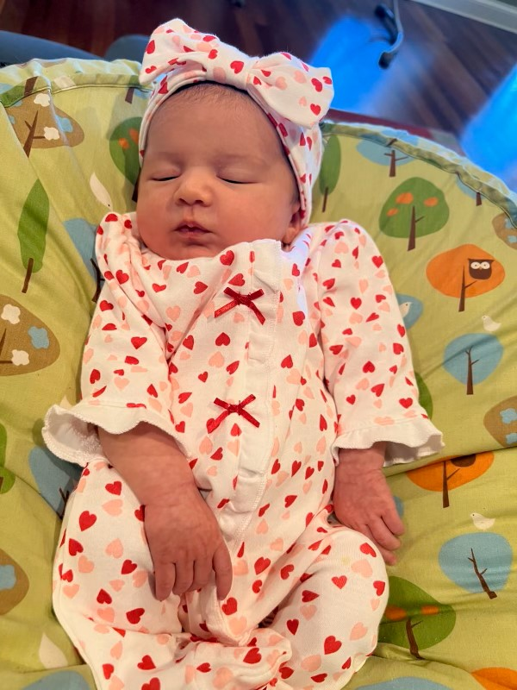

We have a new baby!! Alyssa Belle Blaylock was born January 21, 2022 weighing 8 lbs. 8 ozs. Welcoming her into her new world were her parents Ryan and Christie Blaylock and brothers Jon Ryan and Keegan. Proud Grandmother from Gamma Beta is Lane Hampton.

Debbie Wiggins fell a few weeks ago suffering several broken bones. Following surgery at Huntsville Hospital she has been transferred to NHC HealthCare in Moulton for rehabilitation. Her address during this time is:
300 Hospital St.
Room 107B
Moulton, AL 35650
At this time it is not known how long Debbie will be at this facility.

February Meeting Highlights
Members present during the February meeting at West Hartselle Baptist Church were Lane Hampton, Sherri Peck, Jeanne Ellen Stroh, Beth Milner, Wanda Duncan, Valerie Powell, Brenda Berryman, Jennie Roberts, Dottie Donahue, Carolyn Ellinger, Bonnie Black, Wendy Duffey, and guest, Brittany Tanner.
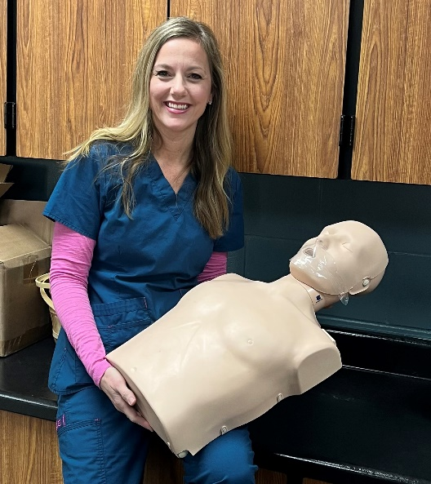
Hartselle City Schools head nurse, Kelli Morton, demonstrates the latest techniques for performing CPR and using an AED.

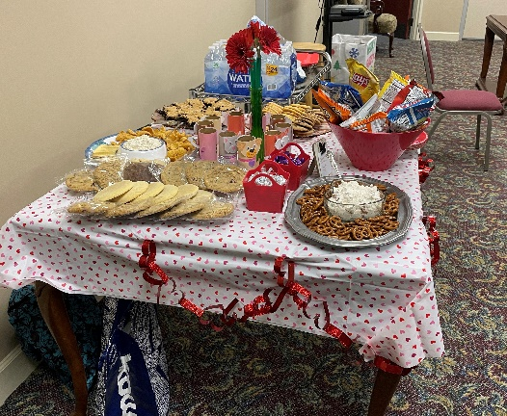
Our hostesses did a wonderful job with the refreshments

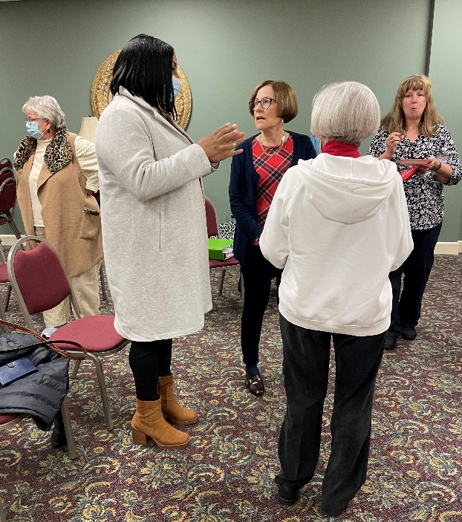
Honored guest at Gamma Beta’s meeting is Brittany Tanner. Brittany was awarded an Early-Career Educator’s Staples card from Gamma Beta. She teaches Business Education at Decatur High School

Business meeting notes:
- Donations were collected for Alabama State’s project Eagles’ Wings
- Dottie Donahue announced the nominated slate of officers for the 2022-2024 biennium. These officers will be voted on during the March meeting.
- Jeanne Ellen Stroh – President
- Beth Milner – Vice President
- Nickie Taylor – Recording Secretary
- Lane Hampton – Corresponding Secretary
- Dottie Donahue – Treasurer
- Jennie Roberts – Parliamentarian
- President Stroh appointed a committee to plan and implement a fundraising event. Serving on this committee are Jeanne Ellen Stroh, Wanda Duncan, Lane Hampton, and Dottie Donahue.

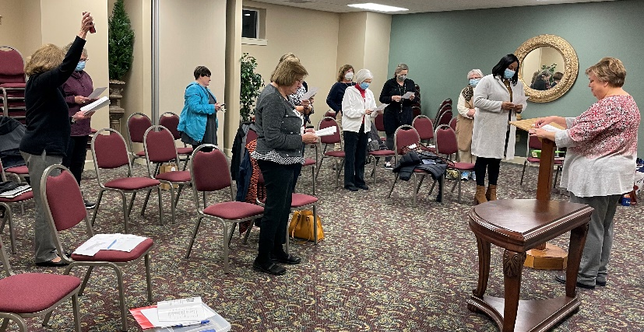
Members sing the Delta Kappa Gamma Song at the close of the business meeting

Gamma Beta Website
Send photos and information to Debby at dmcrow56@gmail.com.
http://gammabetachapter.weebly.com/

Alabama State

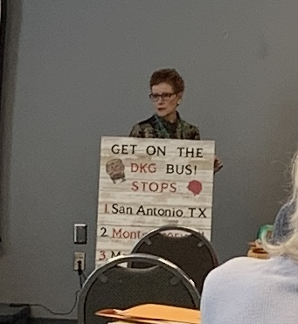
DKG Southeast Regional Director Candi Martin

Leadership day occurred at Delraida Church of Christ in Montgomery on February 19th. Candi Martin, our SE Regional Director, updated the attendees with news from International and information about amendments we will be discussing and voting on in New Orleans at our International Convention.

Mu’s Libby Watson gave a wonderful presentation on managing your time and organizational skills.

Membership Chair, Charlotte Oglesby from Gamma Phi in District IV, read Pete the Cat while attendees described different leadership traits.

Alabama State’s 90th birthday was celebrated with yummy cupcakes.

Gamma Beta members attending the leadership day were Jeanne Ellen Stroh and Debby Crowell.

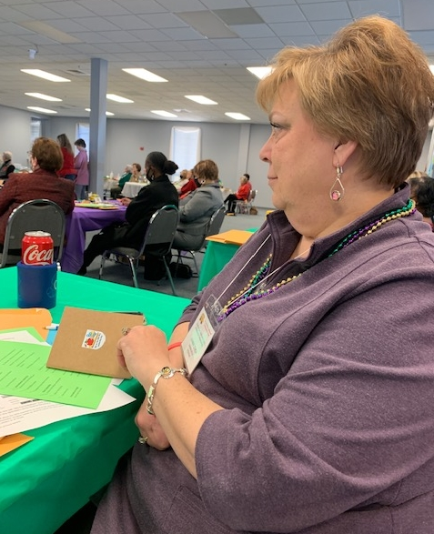
Jeanne Ellen is enthralled with all the International amendments

Weekend of Wonder (WOW) will be in Muscle Shoals October 14-16, 2022. This is a FUN event while getting together with our Alabama State sisters.

March
7th Valerie Powell
14th Jeanne Ellen Stroh
26th Karen Parmer
April
1st Jennie Roberts
21st Ginger Richey

March Meeting
March 3, 2022
4:30 PM
Thursday
Keramos Ceramics
110 Sparkman Street
Hartselle, AL 35640

Devotion: Jeanne Ellen Stroh
Business:
- Vote on the 2022-2024 slate of officers nominated at the February meeting
Program:
- Ceramics
NO REFRESHMENTS WILL BE SERVED

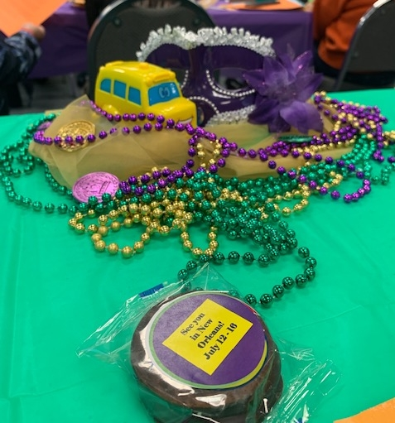

2021-2022 Chapter Meetings and Important Dates

- March 3, 2022 – Gamma Beta Chapter Meeting at Keramos Ceramics – 4:30 PM
- April 7, 2022 – Gamma Beta Meeting at West Hartselle Baptist Church – 4:30 PM – Founders Day Celebration with Mu Chapter – Penny Christian, Alabama State President
- May 1, 2022 – Achievement Award applications due to Allison Hill
- June 3, 2022 – Officer Training Day for all new chapter officers at Delraida Church of Christ, Montgomery
- July 12 – 16, 2022 – International Convention in New Orleans
- October 14-16, 2022 – WOW – Muscle Shoals

