Gamma Beta Newsletter
The Delta Kappa Gamma Society International
March 2023
Gamma Beta Reminder
Dues for the upcoming year are due at the April meeting. If you cannot attend, please put your dues of $80.00 in the mail to Dottie at this address:
Dottie Donahue
15627 Line Road
Athens, AL
Dottie will send you an email when she receives your check. Your canceled check will be your receipt.

Alabama State

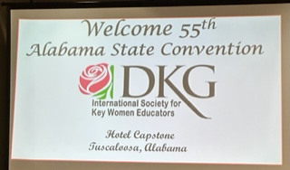
The start of our Alabama State Convention, March 3rd-5th.
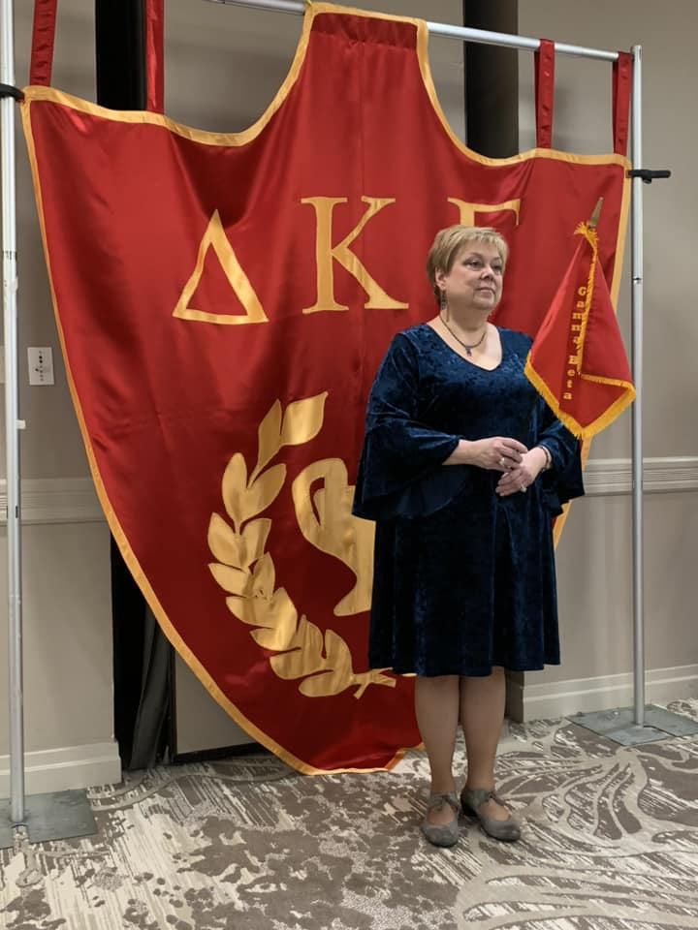

Jeanne Ellen carries the Gamma Beta flag during the procession of chapter presidents.

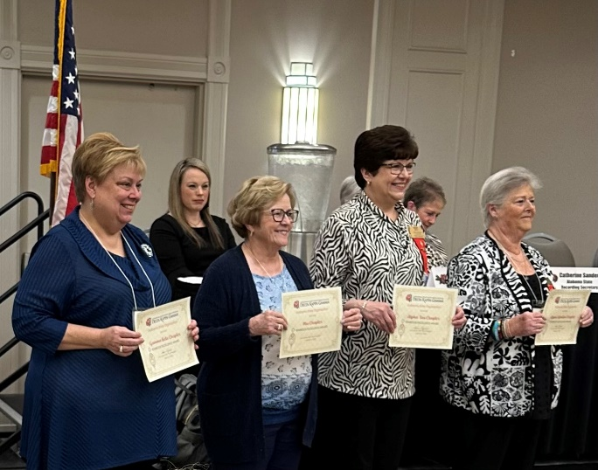
Jeanne Ellen stands with other District 1 Chapter Presidents after receiving the Yearbook Excellence Award

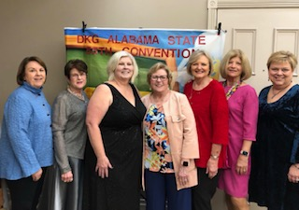
Sisters from Gamma Beta and Mu pose with outgoing Alabama State President Penny Christian
Elected Officers for 2023-2025
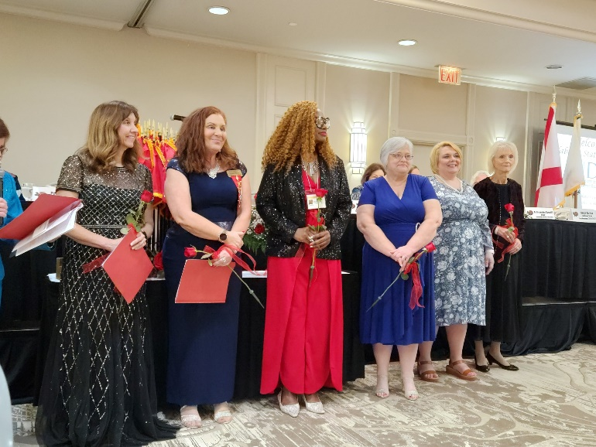
Ann Jones-president, Dawn Pettit-1st vice president, Gennice Burch-2nd vice president, Allison Hill- recording secretary, Amy Stills-corresponding secretary, and Martha Knight-parliamentarian.
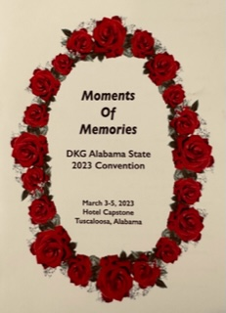
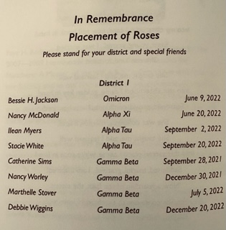
Sisters Catherine Sims, Nancy Worley, Marthelle Stover, and Debbie Wiggins were honored during the Ceremony of Remembrance
Project for International Conference in Detroit, MI
A DKG International cookbook is being compiled to be given away at the International Convention in Detroit. If you have a special “tried and true” recipe that you would like to share please send it to Sharon Storms at sstorms855@gmail.com with the Subject Line of “DKG Recipe” by May 1, 2023. Please include your name, state, and chapter. If you would like to include a few sentences about why this recipe is special to you, that would be great. You may also submit a picture of the finished recipe.
Wild About Leadership
If you have not attended a leadership seminar, don’t let this opportunity pass you by. This year’s seminar will occur June 15th and 16th in Marion, AL. Don’t let the bus forget to pick you up!!

April
1st Jennie Roberts
21st Ginger Richey
May
23rd Dottie Donahue
June
27th Wendy Duffey
July
12th Wanda Duncan
29th Betty Vaughn
29th Debbie Ferguson
August
7th Beth Milner
17th Lane Hampton

Gamma Beta Website
Send photos and information to Debby at dmcrow56@gmail.com.
http://gammabetachapter.weebly.com/
April Meeting
April 6, 2023
4:30 PM
Thursday

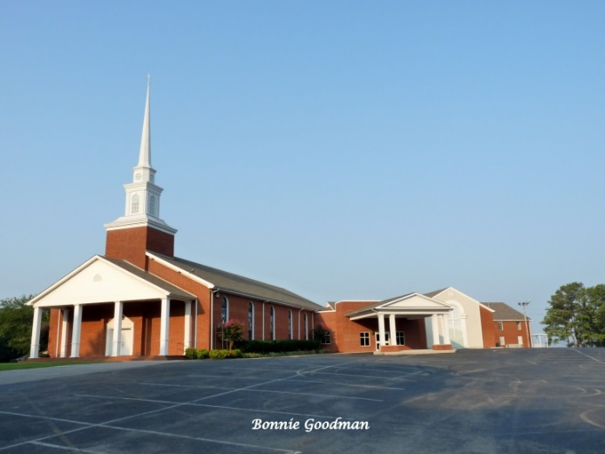
West Hartselle Baptist Church
1640 Main Street West
Hartselle, AL
Joint Meeting with Mu Chapter

Devotion: Sherri Peck
Business:
- Collection of Dues
Program:
- Founder’s Day Celebration
- Chapter Birthday Celebration
- Karissa Lang – Principal Crestline Elementary School - Speaker

HOSTESSES: Dottie Donahue, chair – ALL MEMBERS ARE ASKED TO BRING A FOOD ITEM

2022-2023 Chapter Meetings and Important Dates

- April 6, 2023 – Joint meeting with Mu Chapter – West Hartselle Baptist Church-CHAPTER DUES ARE DUE
- June 15-16, 2023 – Leadership Seminar – Marion, AL.

