**Gamma Beta Newsletter**

The Delta Kappa Gamma Society International

November, 2018

**Member News**

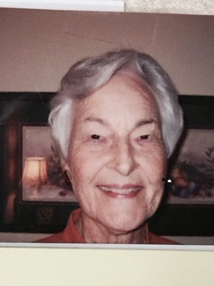

Gamma Beta Charter Member, Faye Walker

Faye Walker, charter member of Gamma Beta, passed away Saturday, October 20, 2018 due to complications from a massive stroke. Visitation will be Thursday, October 25, 2018 from noon till 2 PM at East Highland Baptist Church in Hartselle. The funeral will follow right after the visitation.

Faye had been a member of Gamma Beta since 1965. She was originally a member of our sister chapter Mu until the State asked them to split. Though Faye was reluctant to leave Mu, she was excited about starting a new chapter. Faye, along with 12 other ladies, was initiated into Gamma Beta on May 8, 1965. She also served as Gamma Beta’s president. Faye has stated that it was an honor to be asked to join DKG.

Faye taught Home Economics, Biology and Chemistry at three different schools. At the end of her career she served at the Central Office of Hartselle City Schools. There she did “whatever the superintendent wanted” which included working with federal and adult programs. She retired from education in 1988 but then supervised student teachers from Athens State for several years.

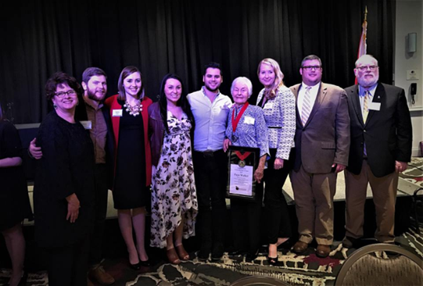

Faye, surrounded by her family when she was inducted into the Morgan County Leadership Hall of Fame, March 9, 2017

Faye is survived by her son Bill, daughter-in-law Jan, and three Grandsons and their spouses.

C:\Program Files (x86)\Microsoft Office\MEDIA\CAGCAT10\j0158007.wmf

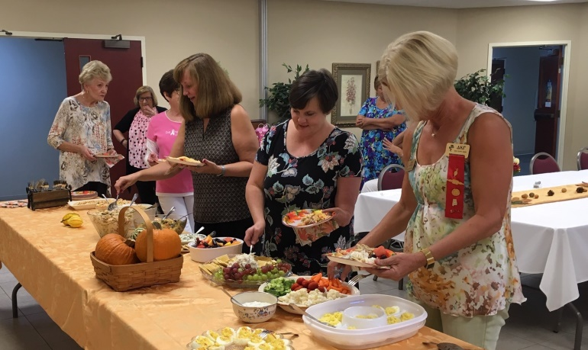

“New” Member Jennie Roberts (2nd from right)

Actually Jennie is a reinstated member voted on during our October meeting. Jennie is a kindergarten teacher at Eastwood Elementary School in Decatur City school district. She was a member of Gamma Beta years ago along with her Mom, Georgia Crane. We welcome her back!! Please add her information to your yearbooks:

Jennie Roberts

1412 Regency Blvd. SE

Decatur, AL 35601

[jencroberts@charter.net](mailto:jencroberts@charter.net)

256-654-2364

Birthday: April 1st

C:\Program Files (x86)\Microsoft Office\MEDIA\CAGCAT10\j0158007.wmf

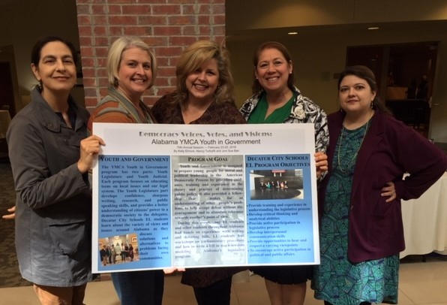

DCS Teachers: Carmen Callahan, Elizabeth House, Dr. Stefanie Underwood, **Joni Bair**, and Nancy Turbyfill

Gamma Beta Chapter member Joni Bair presented at AMTESOL (Alabama/Mississippi Teachers of English to Speakers of other Languages) at the Advocacy Conference in Oxford, MS. Joni spoke about a trip she took to Montgomery, AL last February with her students. Approximately 750 students took part in this program in Montgomery where they learn to advocate for themselves while learning about the Legislative part of our government, YMCA’s Legislative Youth Government. Joni will be taking another group this November for the Judicial Youth Government mock trial. Joni currently teaches at the Excel Center in Decatur. We will look forward to hearing about her upcoming trip!

**October Meeting Highlights**

Our October meeting was held at West Hartselle Baptist Church. The meeting started with a wonderful devotion by Wanda Duncan which recounted the heart-rending yet inspiration trials of her dear friend Jan Schultz. Wanda was also dressed in pink which reminded all in attendance of the significance of searching for a cure for breast cancer.

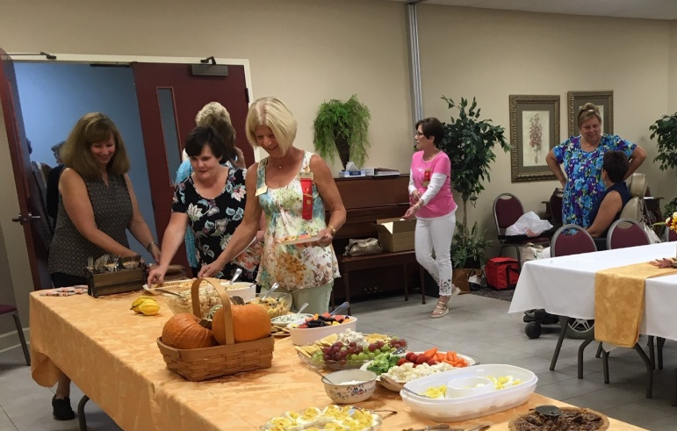

Members helping themselves to the delicious salad and desert supper.

The new yearbooks were distributed to the members present. We received resignations after our yearbook was printed. Please delete their information from your yearbook.

Dottie needs your dues if you have not yet paid them.

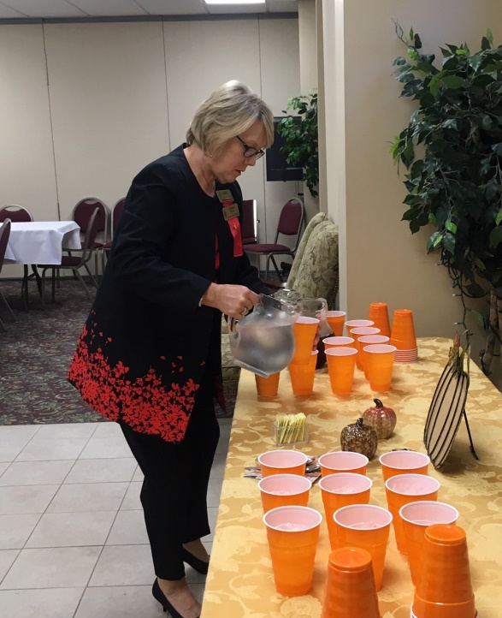

Hostess Sherri Peck serves the beverages.

**Alabama State News**

President, Donna Butler, reminds us of our sisters who have been affected by Hurricane Michael. As of yet she has not been made aware of any specific needs.

**Gamma Beta Website**

Send photos and news to our web master, Debby Crowell. Email her at dmcrow56@gmail.com.

<http://gammabetachapter.weebly.com/>



October

25th Debby Crowell

November

7th Nancy Worley

8th Sherrie Peck

27th Carolyn Ellinger

December

15th Nickie Taylor

22nd Marthelle Stover

**November Meeting**

**Thursday, November 1, 2018**

**4:30 PM**



Freight House Restaurant

200 Railyard St. SW

Hartselle, AL 35640

Devotion: Carolyn Ellinger

Business:

* Alabama State Convention 2/22 – 2/24/2019 Huntsville – Valerie Powell
* Collect for World Fellowship – Nickie Taylor
* Publishing Permission Signatures for Websites – all those who were not in attendance at the October meeting.

Program:

* Holiday shopping safety precautions – Police Department





**2018-2019 Meeting Dates**

* December 1, 2018 – 9:00 AM – Christmas Brunch at Warehouse Coffee Shop, Hartselle
* February 7 – 4:30 PM at Excel Center, Austin Jr. High School, Decatur
* February 22-24 – Alabama State Convention, Embassy Suites, Huntsville
* March 7 – 4:30 PM at OH! Bryan’s Family Steak House, Hartselle
* April 4 – 4:00 PM at Morgan County Board of Education, Priceville (Joint meeting with Mu)