Gamma Beta Newsletter
The Delta Kappa Gamma Society International
November, 2019

Member News

Gamma Beta’s own, Brenda Berryman, was Austin High School’s Grand Marshall for their 2019 Homecoming. Brenda taught math at Austin for 36 years. Aside from her teaching duties, Brenda often worked home sporting events. It was not unusual for her to tote her students with her to continue a tutoring session while she guarded a gate! Brenda also accompanied the chorus on the piano at special ceremonies such as Baccalaureatte and National Honor Society. She is a HUGE supporter of her Black Bears!!
Brenda in Austin’s Homecoming Parade October 10, 2019

October Meeting Highlights

Gamma Beta met at West Hartselle Baptist Church for a salad/dessert supper and fellowship. A nomination committee was chosen and voted on to recommend officers to lead our chapter during the 2020-2022 biennium. If would like to recommend yourself or one of our sisters as an officer please contact the nominations committee.

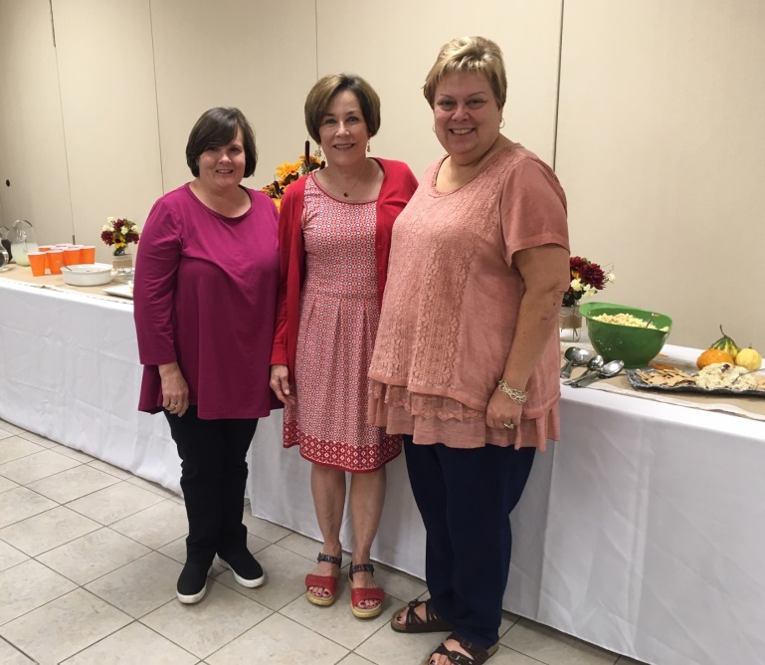
Nominations Committee: Jennie Roberts, Wanda Duncan, and Jeanne Ellen Stroh

Yearbooks were handed out at the October meeting. If you have not received yours please contact Valerie.

Valerie also reminded our membership to log into DKG’s website to check your information and to make any changes. Instructions to do this are attached to the inside cover of your yearbook.

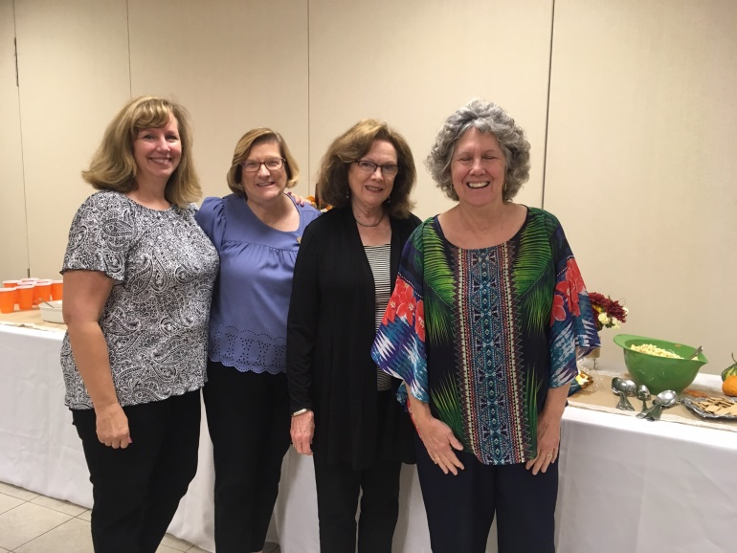
Officers Beth, Valerie, Dottie, and Lane enjoying the Salad Supper

Alabama State News
Who We Are: From Alabama State Website
​ The Alabama State Organization is an organization of the Delta Kappa Gamma Society International, which is a professional honorary society of key women educators. The Society promotes professional and personal growth of its members and excellence in education.
Established in 1929, Delta Kappa Gamma has attained major objectives in improving opportunities for qualified women employed at every level of education, as well as in advancing the status of women educators.
To this end, the Purposes set forth by the Founders continue to embody the spirit of the Society. The Purposes have grown and changed over time, but continue to be as valid in today's contemporary world as when first adopted. The Mission and Vision support the Purposes.
Membership is by invitation only and considered a prestigious honor with a variety of benefits and privileges.

Gamma Beta Website

Send photos to her at dmcrow56@gmail.com.
http://gammabetachapter.weebly.com/

October
25th Debby Crowell
November
7th Nancy Worley
8th Sherrie Peck
27th Carolyn Ellinger

November Meeting
November 2,2019
10:00 AM

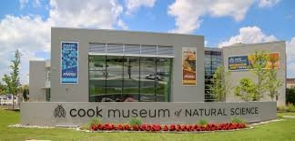

Cook Museum
133 4th Ave.
Decatur, AL

Devotion: Carolyn Ellinger

Business: NO BUSINESS MEETING

Program:
- Tour of Museum
- Adults - $20
- Children - $15
- Seniors (65+) - $17
- Group Rate (20+) – Adults $17 & Children $13
- Lunch at Nature’s Table (On site Cafe)
- Collect for World Fellowship

IMPORTANT!!

All members contact Valerie, 256-345-4615, to let her know if you are attending. Family members and friends are welcome! RSVP by October 28th.

2019-2020 Chapter Meetings and Important Dates

- November 2, 2019 (Saturday), 10:00 AM – Cooks Museum Tour and Lunch
- December 7, 2019 (Saturday), 9:00 AM – Christmas Brunch, Pte. Mallard Estates Clubhouse, Decatur
- February 6, 2020, 4:30 PM – Stone River United Methodist Church, Decatur
- February 29, 2020 – Alabama State Leadership Day, Delraida Church of Christ, Montgomery
- March 5, 2020, 4:30 PM – JW Steakhouse, Priceville
- April 9, 2020, 4:00 PM – Joint meeting with Mu Chapter – Morgan County Board of Education, Room A
- June 5, 2020 – One Day Workshop (replaced District Meetings), Delraida Church of Christ, Montgomery
- July 7-11, 2020 – International Convention, Philadelphia, PA

Looking Ahead

Our December meeting will be our Christmas Brunch on December 7th from 9:00 – 11:00 AM at the Pte. Mallard Estates Clubhouse. All members will be asked to bring a brunch food item to share. There will be a sign-up list at Cook’s when we meet in November 2nd.

