Gamma Beta Newsletter
The Delta Kappa Gamma Society International
November 2021

October Meeting Highlights

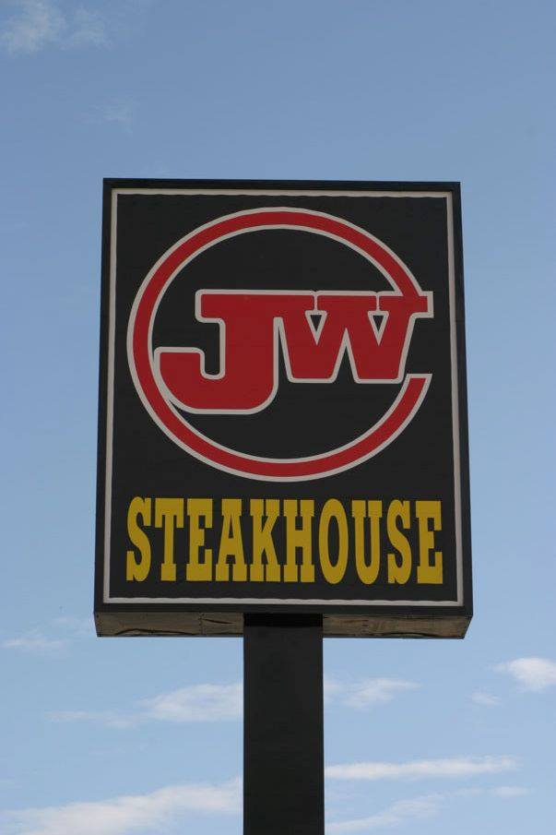

Gamma Beta met at JW Steakhouse in Priceville on October 14th, 2021. Members present were: Jennie Roberts, Valerie Powell, Wanda Duncan, Nickie Taylor, Beth Milner, Lane Hampton, Jeanne Ellen Stroh, Ginger Richey, and Carolyn Ellinger.
- A motion was made and approved to return the $45 that Billy Sims paid for Catherine’s reserve membership dues. A bracelet awarded to Catherine for her 50 years of membership in DKG will be given to Billy when the check is delivered to him.
- Dinner and fellowship followed the business meeting. Active teachers shared their experiences starting out the new year and the challenges they face due to COVID. Retired teachers agreed that it was a good time to be retired!

Gamma Beta Website
Send photos and information to Debby at dmcrow56@gmail.com.
http://gammabetachapter.weebly.com/

Alabama State

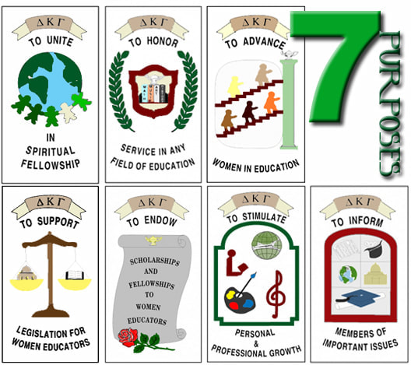
DKG Seven Purposes

From Penny Christian: Go to MY DKG Account and update your email, phone number and address. As we work on the directory, we will be able to update this information. This information is vital so that we can all stay connected. You will need your membership # to do this.

November
7th Nancy Worley
8th Sherrie Peck
27th Carolyn Ellinger

December
15th Nickie Taylor
22nd Marthelle Stover

November Meeting
November 4, 2021
4:30 PM
Thursday
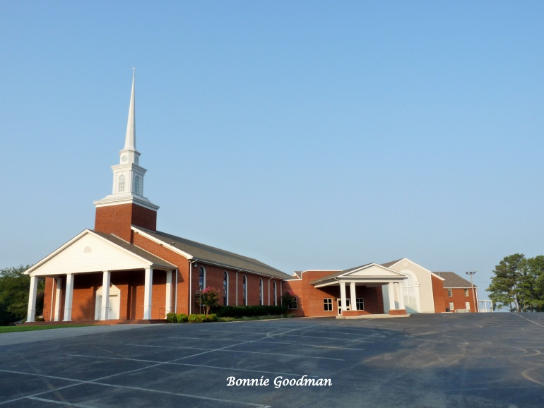
West Hartselle Baptist Church
1640 Main St. W., Hartselle, AL
35640

Devotion: Carolyn Ellinger

Business:
- Scholarship Committee Update

Program: Shawn Guthrie from AAA
- Current popular travel destinations
- Changes in travel due to COVID
- Why use a travel agent?

Hostesses: Lane Hampton chair, Jo Ann Sneed, Ginger Richey, Sherri Peck, Carolyn Ellinger

2021-2022 Chapter Meetings and Important Dates

- November 4, 2021 – Gamma Beta Chapter Meeting at West Hartselle Baptist Church – Shawn Guthrie AAA Travel Agent
- December 4, 2021 – Gamma Beta Chapter Meeting at Debby Crowell’s Home – 9:00 AM - Christmas Brunch
- December 19, 2021 – Alabama State’s 90th birthday
- February 3, 2022 – Gamma Beta Chapter Meeting at West Hartselle Baptist Church – 4:30 PM - CPR Demonstration
- February 19, 2022 – Leadership Day at Delraida Church of Christ, Montgomery
- March 3, 2022 – Gamma Beta Chapter Meeting at Keramos Ceramics – 4:30 PM
- April 7, 2022 – Gamma Beta Meeting at West Hartselle Baptist Church – 4:30 PM – Founders Day Celebration with Mu Chapter – Penny Christian, Alabama State President
- June 3, 2022 – Officer Training Day for all new chapter officers at Delraida Church of Christ, Montgomery

