Gamma Beta Newsletter
The Delta Kappa Gamma Society International
November 2022
Member News

Please put Alabama DKG State conference on your calendar. The conference will be held in Tuscaloosa March 3-5, 2023. We will have 3 members memorialized at the Ceremony of Remembrance Sunday morning March 5th; Catherine Sims, Nancy Worley, and Marthelle Stover. It would be wonderful if a group of us could attend to honor them.

October Meeting Highlights

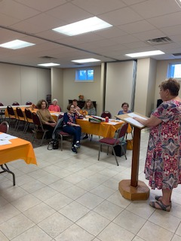
President, Jeanne Ellen Stroh, conducts Gamma Beta’s business meeting

- Members present were: Lane Hampton, Jeanne Ellen Stroh, Dottie Donahue, Carolyn Ellinger, Valerie Powell, Beth Milner, Nickie Taylor, Wanda Duncan, Jennie Roberts, and Debby Crowell
- A short business meeting was conducted by Jeanne Ellen where the 2022-2023 budget was approved. Yearbooks were distributed. Discussion took place regarding ideas for a fundraiser. The new requirements to qualify for the Order of the Rose were discussed.
- Members enjoyed a delicious salad and dessert supper!

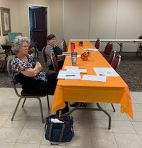
Jennie and Lane paying special attention to the business meeting

Gamma Beta Website
Send photos and information to Debby at dmcrow56@gmail.com.
http://gammabetachapter.weebly.com/

Alabama State

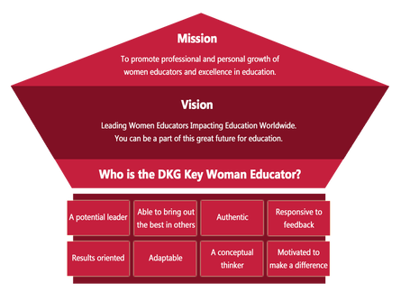
An updated Order of the Rose form can be found on the Alabama DKG website at: FORMS - THE DELTA KAPPA GAMMA SOCIETY INTERNATIONAL: ALABAMA STATE ORGANIZATION (weebly.com)
Below is a section of the form that we can all help out with. At our October meeting we had 50% of our membership present which would earn us 2 pts. It would be fun and profitable to all of us if we were able to earn 3 pts. by having over 51% average at our meetings. Let’s do it!
1.Induct/reinstate one member. July 1, 2022-June 30, 2024 Member name: 6 points
1.Induct/reinstate one member. July 1, 2022-June 30, 2024 Member name: 6 points
2. Induct or reinstate 3 or more additional members July 1, 2022- June 30, 2024 1______________ 2______________ 3______________ 1 point
3.Maintain all members from previous year (excludes deaths or transfers) July 2022-June 2023
Yes/ No 1 point July 2023-June 2024 Yes /No 1 point
4. Meeting attendance averaged.
(Virtual counts) July 1, 2022- June 30, 2024 Number attending: Percentage: 10-30% 1 pt. 31-50%- 2 pts. 51% plus- 3 pts.

2. Induct or reinstate 3 or more
additional members July 1, 2022- June 30, 2024 1______________ 2______________ 3______________ 1 point
3.Maintain all members from previous
year (excludes deaths or transfers) July 2022-June 2023 Yes No 1 point July 2023-June 2024 Yes No 1 point
4. Meeting attendance averaged.
(Virtual counts) July 1, 2022- June 30, 2024 Number attending: Percentage: 10-30% 1 pt. 31-50%- 2 pts. 51% plus- 3 pts.

November
8th Sherri Peck
27th Carolyn Ellinger

December
15th Nickie Taylor

November Meeting

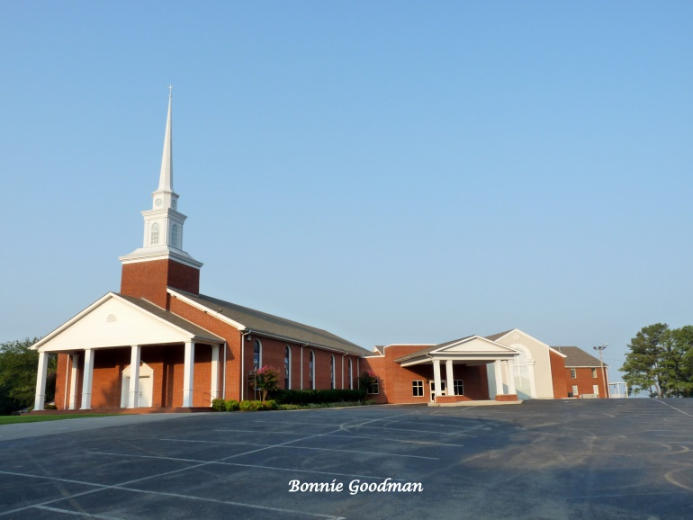
November3, 2022
4:30 PM
Thursday
West Hartselle Baptist Church
1640 Main St. W.
Hartselle, AL 35640

Devotion: Carolyn Ellinger
Business:
- Gamma Beta Scholarship Committee Updates
- Collect for World Fellowship
Program:
- Christmas Craft – Please bring $3-$5 (exact change please) to cover the cost of your craft.

Hostesses for this meeting: Jennie Roberts-Chair, Karen Parmer, Dottie Donahue, Jo Ann Sneed, Wanda Duncan

2022-2023 Chapter Meetings and Important Dates

- November 3, 2022 – Gamma Beta meeting – West Hartselle Baptist Church – Christmas craft
- December 3, 2022 – Christmas Brunch – Home of Debby Crowell
- February 1, 2023 – Deadline for Alabama State’s scholarship application submission
- February 3, 2023 – Gamma Beta Meeting – West Decatur Elementary School – Team Building
- March 2, 2023 – Gamma Beta Meeting – Athens State University
- March 3-5, 2023 – Alabama DKG State Convention - Tuscaloosa
- April 6, 2023 – Joint meeting with Mu Chapter – West Hartselle Baptist Church

