Gamma Beta Newsletter
The Delta Kappa Gamma Society International
November 2023

Gamma Beta Member News

Gamma Beta April Meeting Highlights

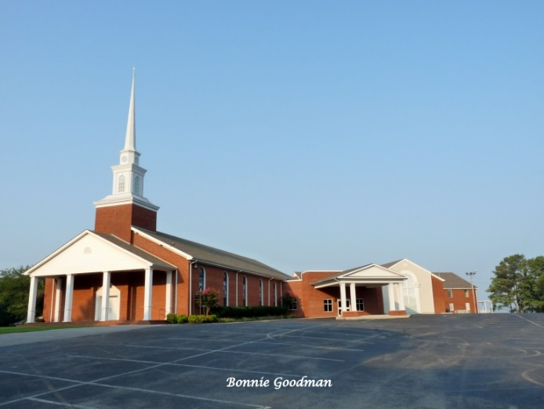

- Gamma Beta met together at West Hartselle Baptist Church on October 5th.
- Members present were Corkey Vann, Brenda Berryman, Carolyn Ellinger, Ginger Richey, Sherri Peck, Jeanne Ellen Stroh, Dottie Donahue, Lane Hampton and Wanda Duncan.
- Jeanne Ellen Stroh gave the devotional.
- Minutes were read and approved from April’s meeting.
- The treasurer’s report was given and approved.
- The 2023-2024 budget was approved.
- The yearbooks were distributed.
- A salad supper and fellowship were enjoyed by the members.

Alabama State

Alabama State Project

Our Mission
To improve services for individuals with Autism Spectrum Disorders and their families through education and advocacy.
Our Vision
To have every individual with autism be understood, be accepted and supported in all community spaces.

Constituency
Individuals with Autism Spectrum Disorders and their families

Beliefs
- Every individual has inherent worth and dignity
- Inclusion in the community is preferred over exclusion
- Options and opportunities should be available for every person
- Services should focus on the family and the individuals
- Accessible, individualized, comprehensive services should be available
- Services should strive to be a model of excellence and incorporate validated innovations
- Consumers should expect and receive effective advocacy and leadership
- Consumers deserve to receive current information on diverse therapeutic options

Introducing Alabama State’s New First Vice President 2023-2025 Biennium

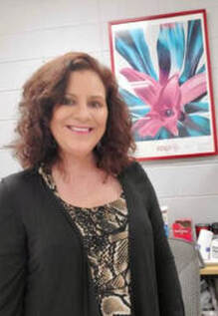
Dawn Pettit
Delta (VI)
Dpettit3@yahoo.com
Dawn Pettit is a Spanish teacher at Monroe County High School in Monroeville and is a member of Delta Chapter, District VI. She has served locally as Chapter President and Chairman of the Grant in Aid Committee. At the state level, she has served as Chairman of the Achievement Award committee, District VI Director, and is currently the Alabama State Second Vice President. Dawn enjoys being actively involved in DKG. She has attended state and international conferences, numerous fall boards, leadership days, and Beta State Leadership Seminar. She has enjoyed her different leadership roles within DKG and is looking forward to the next step of her Delta Kappa Gamma journey.

November
8th Sherrie Peck
27th Carolyn Ellinger

December
15th Nickie Taylor

November Meeting
November 2, 2023
4:30 PM
Thursday

Keramos Ceramics
110 Sparkman Street
Hartselle, AL 35640

Devotion: Carolyn Ellinger
Business:
- Gamma Beta Scholarship Committee Updates
Program:
- Ceramics-members will pick out what piece they would like to complete.

NO REFRESHMENTS WILL BE SERVED

RSVP TO LANE HAMPTON BY OCTOBER 30TH IF YOU PLAN ON ATTENDING THIS EVENT.
Lane Hampton
Lhampton11@aol.com
Cell: 256-318-3660

Gamma Beta Website
Send photos and information to Debby at dmcrow56@gmail.com.
http://gammabetachapter.weebly.com/

2023-2024 Chapter Meeting Dates
- November 2 - Keramos Ceramics
- December 2 - Brunch and new member initiation at Debby Crowell's home
- Feb. 1 – Meet with Mu at Turner-Surles Community Center – Speaker will be Peggy Allen Towns
- March 7 – Alabama State President Ann Jones and District 1 Director Tamra Counts will visit Gamma Beta and Mu at Central Baptist in Decatur
- April 4 - Athens State University tour of McCandless Music Hall and Founders Day program

