Gamma Beta Newsletter
The Delta Kappa Gamma Society International
October, 2018

Member News
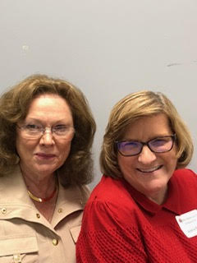
Dottie and Valerie at Fall Board meeting on August 18th in Montgomery.

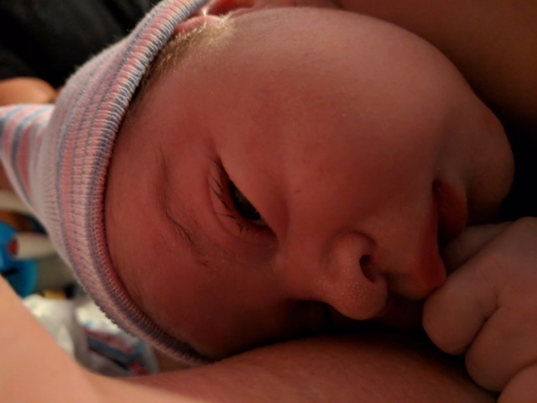

Congratulations to Wendy and Jason Duffey on the birth of their first Grandchild, Eoghan Norman Duffey, pronounced Owen.

Parents: Jack and Makaylyn Duffey
Born: September 19, 2018
Size: 8 lbs. 3.9 oz. and 21 ¼ inches long

So happy for you Wendy!!

International Constitutional Changes That Affect Chapters

- We are now the Alabama State Organization of Delta Kappa Gamma Society International (No longer Beta State).
- Members will now be inducted NOT initiated.
- An individual becomes a member when she pays her dues.
- A 4th classification of membership has been added; collegiate.
- Payment of dues and fees has been realigned to coincide with the fiscal year, July 1 – June 30th, beginning June 30, 2019.

Gamma Beta Website
Send photos and news to Debby Crowell.
Email her at dmcrow56@gmail.com
Our former member Debbie Kirby has volunteered to keep our web page up-to-date.
http://gammabetachapter.weebly.com/

September
5th Corkey Vann
6th Dawn Carroll
10th Catherine Sims
14th Brenda Berryman

October
25th Debby Crowell

October Meeting

Salad Supper/Get to Know Your Fellow Members
Thursday, October 4, 2018
5:00 PM

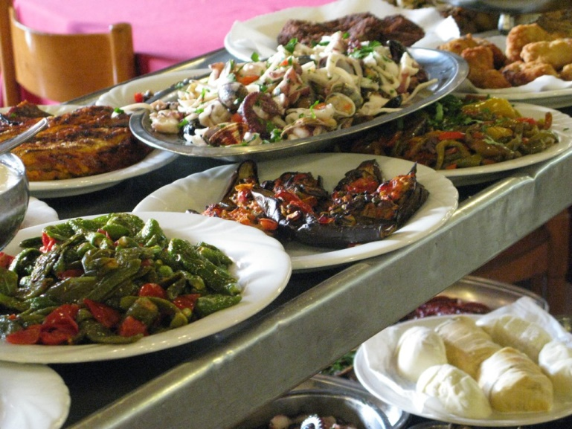

West Hartselle Baptist Church
1640 Main St. W.
Hartselle, AL

Devotion: Wanda Duncan
Business:
- Yearbook Distribution – Beth Milner
- Recruitment Grant Committee – Sherri Peck
- Gamma Beta Projects – Valerie Powell
- Gamma Beta Scholarship Committee – Beth Milner
- Publishing Permission Signatures for Websites
Program:
- Get to know your fellow
- Collect for World Fellowship
Hostesses: Lane Hampton (chair), Jo Ann Snead, Brenda Berryman, Dawn Carroll, Carolyn Ellinger

All members are asked to bring a salad or dessert to share.

2018-2019 Meeting Dates

- November 1 – 4:30 PM at Freight House Restaurant, Hartselle
- December 1, 2018 – 9:00 AM – Christmas Brunch at Warehouse Coffee Shop, Hartselle
- February 7 – 4:30 PM at Excel Center, Austin Jr. High School, Decatur
- February 22-24 – Alabama State Convention, Embassy Suites, Huntsville
- March 7 – 4:30 PM at OH! Bryan’s Family Steak House, Hartselle
- April 4 – 4:00 PM at Morgan County Board of Education, Priceville (Joint meeting with Mu)

