Gamma Beta Newsletter
The Delta Kappa Gamma Society International
October, 2019

Member News

Congratulations to Valerie Powell on the birth of her newest Grandchild! Larkin Grace Powell was born on April 4, 2019. Big brother Charles and big sister Elizabeth share in her joy!!

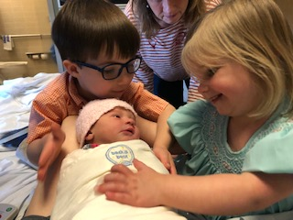
Charles and Elizabeth welcome Larkin Grace

April Meeting Highlights

Gamma Beta met at Walter Jackson Elementary School in Decatur for a joint meeting with Mu Chapter. We were treated to a demonstration by Walter Jackson’s Robotics Team. Afterwards were given out for outstanding accomplishments where our own Ginger Richey was recognized for completing her doctorate degree. The guest speaker for the meeting was 2017-2019 Alabama State President Donna Butler. Both chapters enjoyed fellowship and delicious refreshments provided by Gamma Beta.

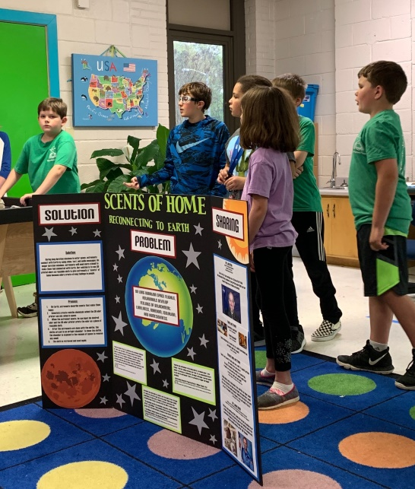
Walter Jackson Robotics Team
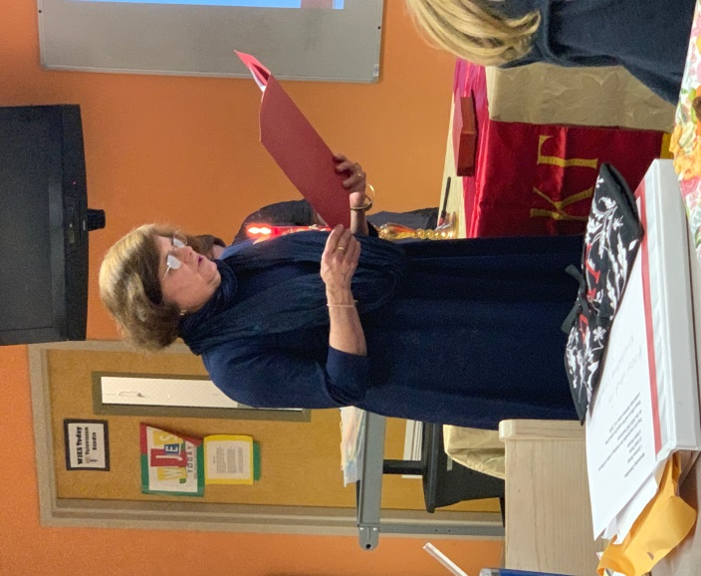
Donna Butler takes part in the member initiation program.
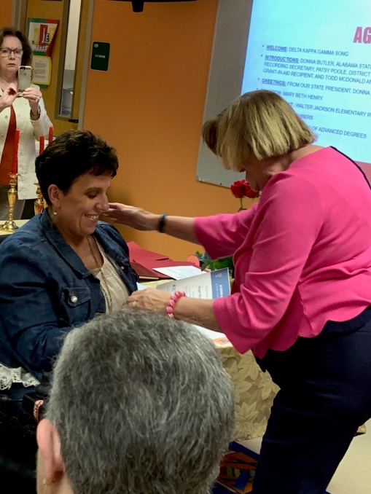
Ginger Richey receives an achievement award from Valerie Powell
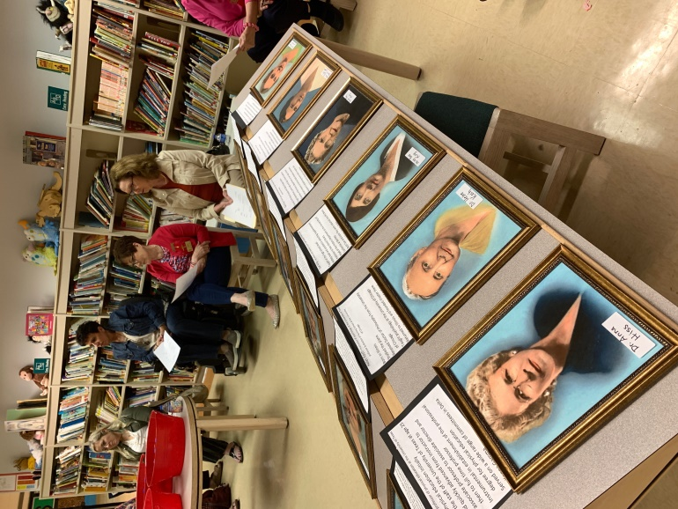
Gamma Beta’s Founders Day Program

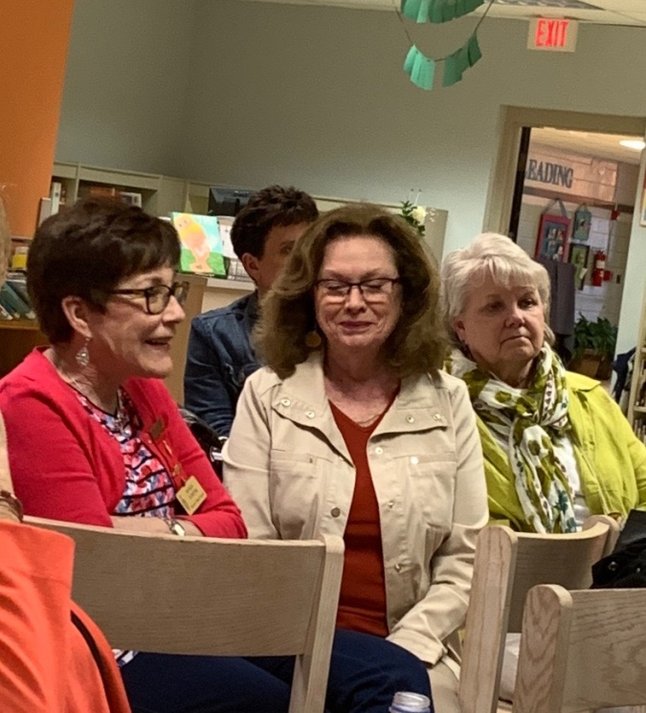
Wanda, Dottie, and Bonnie take part in Gamma Beta’s Business Meeting

Alabama State News

Gamma Beta’s Debby Crowell will be serving as District 1 Director for the 2019-2021 Biennium.

Alabama State Fall Board was held on August 17, 2019 at Delraida Church of Christ in Montgomery. Attending from our chapter were Valerie Powell, Dottie Donahue, and Debby Crowell. Approximately 150 members of Delta Kappa Gamma attended this mandatory event.

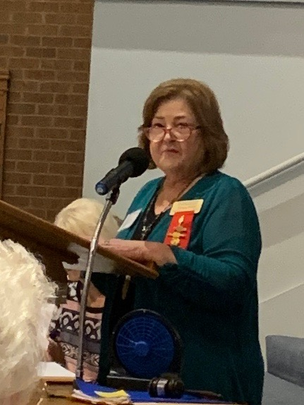
Alabama State President Teresa Noell presides over the business meeting at Fall Board

The Alabama State website has been re-designed by our new webmaster Amy Crew. Take time to browse through the site: https://alabamadkg.weeble.com

Gamma Beta Website

Send photos to her at dmcrow56@gmail.com.
http://gammabetachapter.weebly.com/

August
7th Beth Milner
17th Lane Hampton
September
5th Corkey Vann
6th Dawn Carroll
10th Catherine Sims
14th Brenda Berryman
October
25th Debby Crowell

October Meeting
October 10,2019
5:00 PM

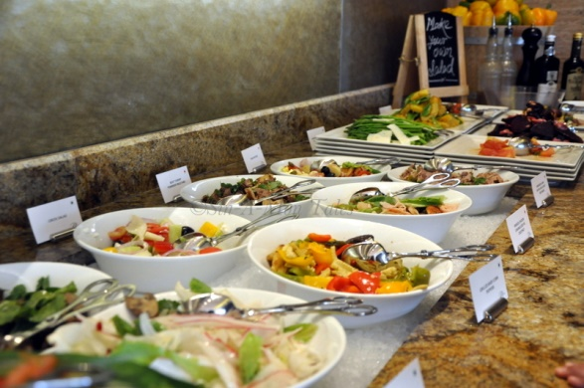

West Hartselle Baptist Church
1640 Main Street W., Hartselle, AL

INVITE PROSPECTIVE MEMBERS TO THIS MEETING

Devotion: Wanda Duncan

Business:
- Distribute Yearbooks
- Vote on nominating committee
- Recruitment Grant Committee
- Gamma Beta Projects
- Gamma Beta Scholarship Committee

Program:
- Salad Supper
- Fellowship
- Collect for World Fellowship

Hostesses: Lane Hampton (chair), JoAnn Sneed, Ginger Richey, Dawn Carroll, Sherri Peck, Carolyn Ellinger, Debbie Ferguson

All members bring a salad or dessert to share. The hostesses will provide beverages.

2019-2020 Chapter Meetings and Important Dates

- November 2, 2019 (Saturday), 10:00 AM – Cooks Museum Tour and Lunch
- December 7, 2019 (Saturday), 9:00 AM – Christmas Brunch, Pte. Mallard Estates Clubhouse, Decatur
- February 6, 2020, 4:30 PM – Stone River United Methodist Church, Decatur
- February 29, 2020 – Alabama State Leadership Day, Delraida Church of Christ, Montgomery
- March 5, 2020, 4:30 PM – JW Steakhouse, Priceville
- April 9, 2020, 4:00 PM – Joint meeting with Mu Chapter – Morgan County Board of Education, Room A
- June 5, 2020 – One Day Workshop (replaced District Meetings), Delraida Church of Christ, Montgomery
- July 7-11, 2020 – International Convention, Philadelphia, PA

Looking Ahead

Our November meeting will be at the new Cook’s Museum on 4th Avenue in Decatur. Due to the hours of operation we are meeting on Saturday, November 2nd at 10:00 AM. We will need a head count of who will be able to attend this event. If we have 20 attending we will receive a group rate, so invite family members to come with you. Admission to the museum is $20/adult. Those who are able will enjoy lunch after the tour in their restaurant. More information will be given at our October meeting.

