Gamma Beta Newsletter
The Delta Kappa Gamma Society International
October, 2020

Installation of Officers

Gamma Beta’s Administrative Board met at the home of Debby Crowell on September 9, 2020 to plan this year’s meetings and to install our officers. The following members were installed as our 2020-2022 Gamma Beta officers.

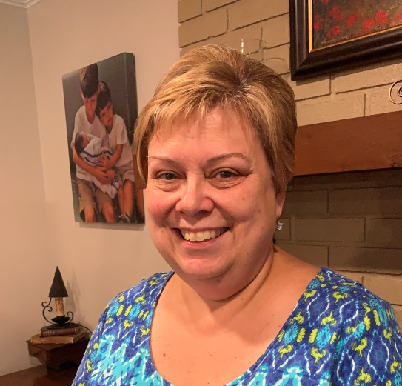
President: Jeanne Ellen Stroh
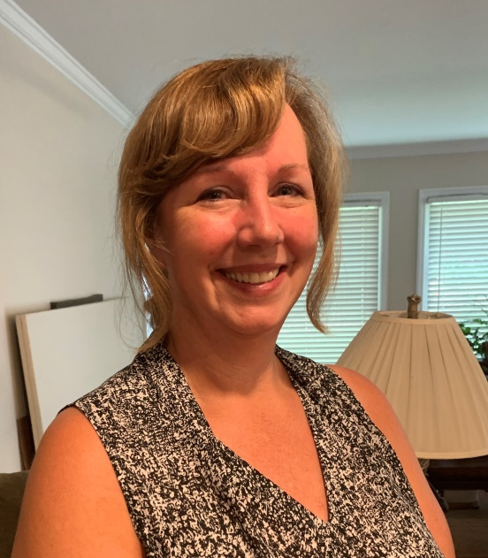
Vice President: Beth Milner
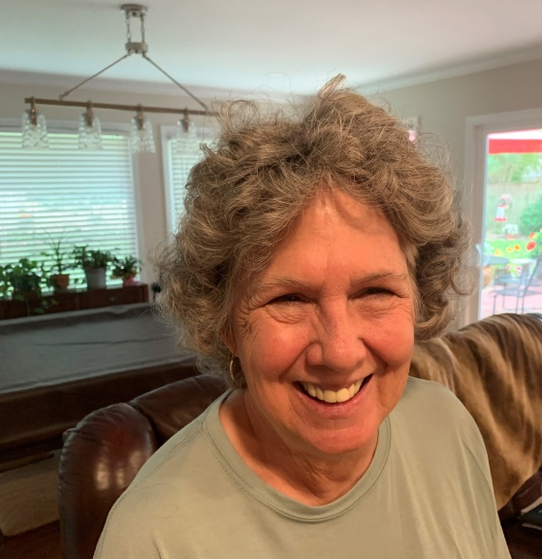
Recording Secretary: Lane Hampton
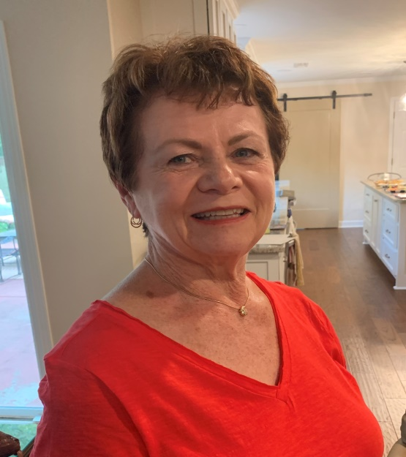
Nickie Taylor: Corresponding Secretary
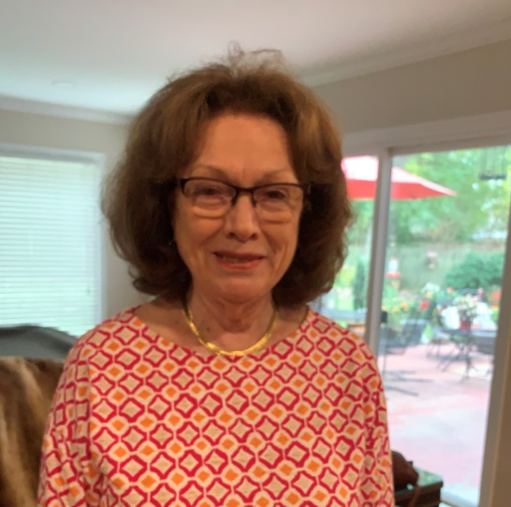
Dottie Donahue: Treasurer
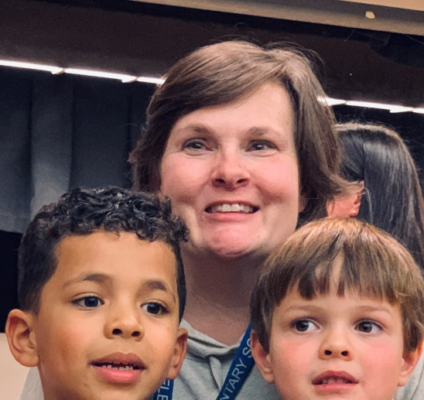
Parliamentarian: Jennie Roberts

The administrative board also planned out the meetings for this coming year. Due to Covid-19, it was decided that we would schedule only four meetings. West Hartselle Baptist Church has graciously opened up its facility to us for our meetings so that we can adequately social distance. The 2020-2021 meeting dates are:

- November 5, 2020 – 4:30 PM
- February 4, 2021 – 4:30 PM
- March 4, 2021 – 4:30 PM
- April 8, 2021 – 4:30 PM

There will be hostesses assigned to each meeting. All snacks and drinks will be pre-packaged for added safety to our members and to limit contact with the church facilities.

Member News
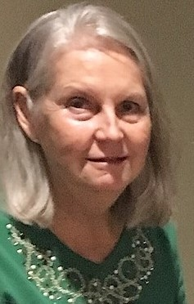
Please keep our newest Gamma Beta member, Debbie Wiggins, in your thoughts and prayers as she recuperates from a broken pelvis and tail bone.

Nic Powell, son of Valerie Powell, is currently doing dialysis at home and doing well. He was told that he needs to get some of the fluid off with the dialysis before more testing can be done. Once the testing is complete he will be placed on a list for a kidney transplant. The transplant will take place at either Vanderbilt or UAB. We hope that can happen soon Valerie!!

Gamma Beta Website
Send photos and information to Debby at dmcrow56@gmail.com.
http://gammabetachapter.weebly.com/

October
25th Debby Crowell

November
7th Nancy Worley
8th Sherrie Peck
27th Carolyn Ellinger

December
15th Nickie Taylor
22nd Marthelle Stover

January
2nd Bonnie Black

November Meeting
November 5, 2020
4:30 PM
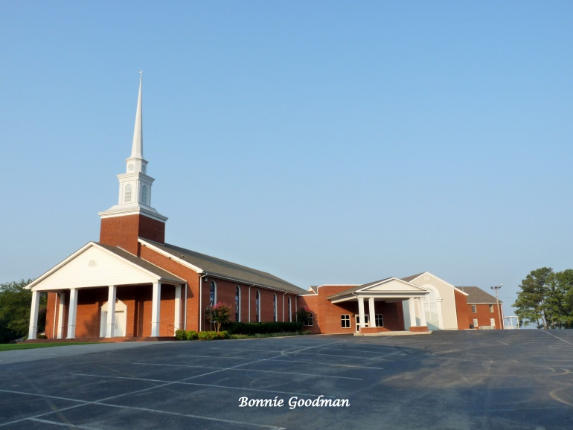
West Hartselle Baptist Church
1640 Main Street W.
Hartselle, AL 35640
Devotion: Wanda Duncan
Business:
- Supporting Early Educators Grant Committee
- Gamma Beta Projects
- Gamma Beta Scholarship Committee
- Yearbooks
Program:
- Professional interest and position of women in Education.

Hostesses: Debby Crowell (chair), Jo Anne Sneed, Ginger Richey, Sherri Peck, Carolyn Ellinger

NOTE: Members are asked to bring a wrapped Christmas gift for a nursing home resident. Note on the package if the gift is for a female, male, or either.

2020-2021 Chapter Meetings and Important Dates

- February 4, 2021 – Gamma Beta Chapter Meeting at West Hartselle Baptist Church – 4:30 PM
- February 20, 2021 – Alabama State One Day Convention
- March 4, 2021 – Gamma Beta Chapter Meeting at West Hartselle Baptist Church – 4:30 PM
- April 8, 2021 – Gamma Beta Chapter Meeting at West Hartselle Baptist Church – 4:30 PM
- June 2021 – Leadership Weekend at

