Gamma Beta Newsletter
The Delta Kappa Gamma Society International
October 2021

Member News
Catherine Sims
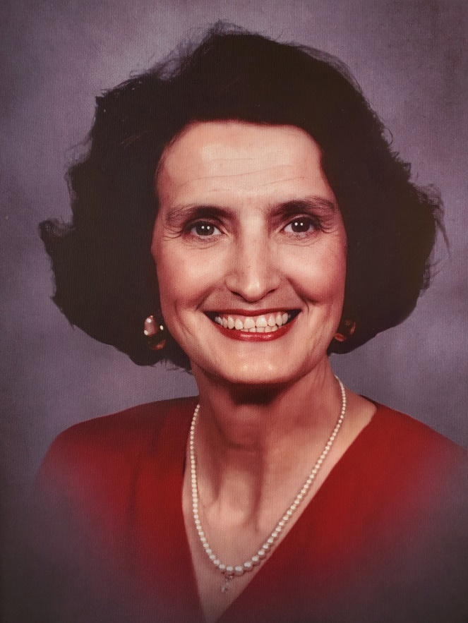
Our long-time member and past president, Catherine Sims, went peacefully to her heavenly home on September 25, 2021. According to Lane Hampton she was a FABULOUS biology teacher! She taught at Hartselle High School where she also was the cheerleading sponsor. Catherine was recently awarded the Order of the Golden Rose in recognition of over 50 years of membership in Delta Kappa Gamma. Please keep Catherine’s husband Billy, her son, grandchildren, and great-grandchildren in your thoughts and prayers.

Debbie Wiggins has moved into Morningside Assisted Living.
2115 Pt. Mallard Dr. SE,
Decatur AL 35601
Room 134
256-466-8806
Debbie’s speech has been affected by Parkinson’s so she has trouble talking, but she would love to hear from us.

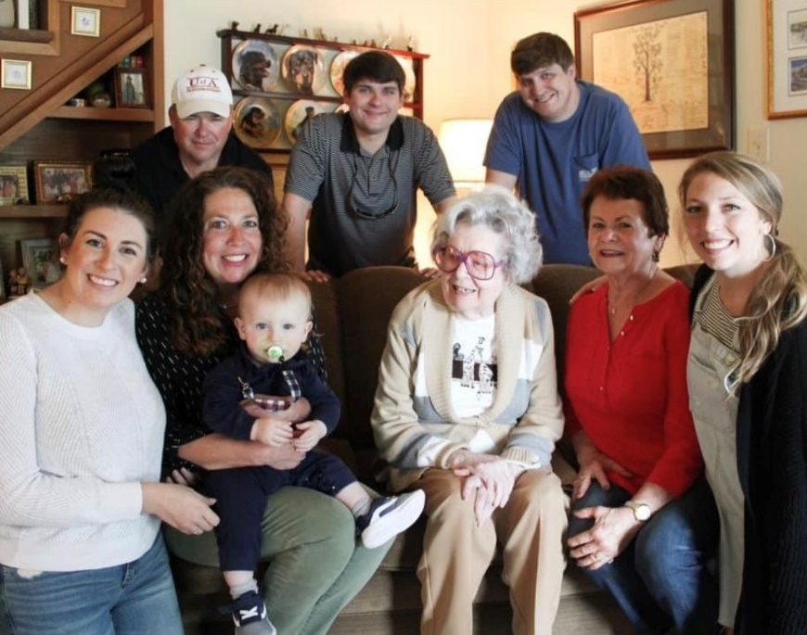
Nickie Taylor and family pose for a 5 generation photo (you read that right). Front: Meredith(4) , Wendy, Brooks (5), Patty (1), Nickie (2), Lauren Back: Lee (3), Tyler, Kevin

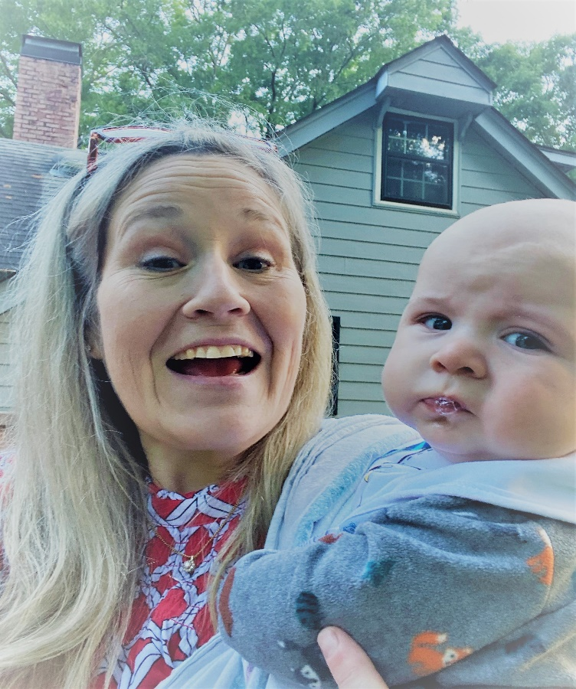
Wendy Duffey enjoys special time with Grandson #2, EaKen Gary Duffey, born December 21, 2020.

Alabama State News

Fall Board
Jeanne Ellen, Dottie, and Debby attended Fall Board on August 14, 2021 at Delraida Church of Christ in Montgomery. After the Administrative Business meeting there were several breakout sessions for chapter officers and Alabama State Committee members.
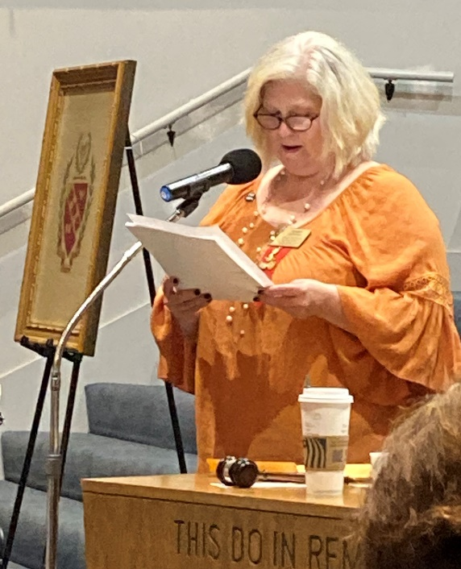
Penny Christian conducting the administrative board meeting at Fall Board

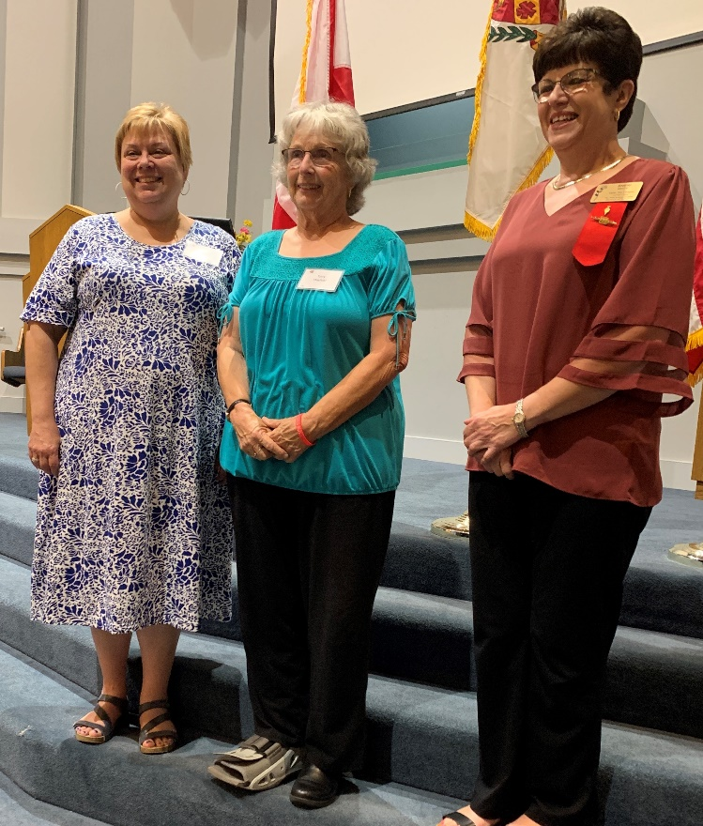
Jeanne Ellen with District 1 Presidents at Fall Board

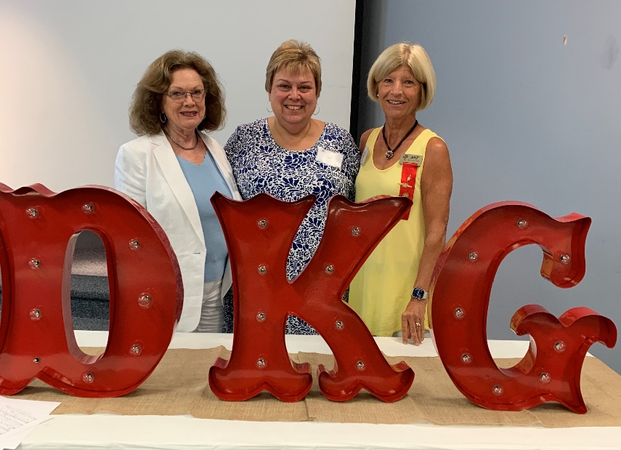
Dottie, Jeanne Ellen, and Debby at Alabama State Fall Board at Delraida Church of Christ, Montgomery

Gamma Beta Website
Send photos and information to Debby at dmcrow56@gmail.com.
http://gammabetachapter.weebly.com/

October
25th Debby Crowell

November
7th Nancy Worley
8th Sherrie Peck
27th Carolyn Ellinger

October Meeting
October 14, 2021
Thursday
4:30 PM
JW Steakhouse
45 Marco Drive
Decatur, AL

Devotion: Wanda Duncan
Business:
- Approve 2021-2022 Budget
- Gamma Beta Projects
- Committee Reports – Supporting Early Education Grant/Gamma Beta Scholarship
- Yearbooks

Program:
- Dinner - Dutch treat
- Collect for World Fellowship
- Gamma Beta Fellowship

2021-2022 Chapter Meetings and Important Dates

- November 4, 2021 – Gamma Beta Chapter Meeting at West Hartselle Baptist Church – Scott Stadthagen
- December 4, 2021 – Gamma Beta Chapter Meeting at Debby Crowell’s Home – 9:00 AM - Christmas Brunch
- February 3, 2022 – Gamma Beta Chapter Meeting at West Hartselle Baptist Church – 4:30 PM - CPR Demonstration
- February 19, 2022 – Leadership Day at Delraida Church of Christ, Montgomery
- March 3, 2022 – Gamma Beta Chapter Meeting at Keramos Ceramics – 4:30 PM
- April 7, 2022 – Gamma Beta Meeting at West Hartselle Baptist Church – 4:30 PM – Founders Day Celebration with Mu Chapter – Penny Christian, Alabama State President
- June 3, 2022 – Officer Training Day for all new chapter officers at Delraida Church of Christ, Montgomery

