Gamma Beta Newsletter
The Delta Kappa Gamma Society International
October 2022
Member News

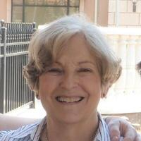
Marthelle Stover member of Gamma Beta since February 2, 1989

Marthelle Williams Stover, 86, of Decatur, died peacefully at home Tuesday, July 5, 2022. A celebration of life will be held this fall at Central United Methodist Church. A graveside service will be held at a later date at Memorial Park Cemetery in Camden Arkansas.

Marthelle was born December 22, 1935, in Paragould, Arkansas, where her father was serving as a District Superintendent for the Methodist Church. After growing up as a preacher’s daughter in several north Arkansas towns, she graduated from Hendrix College, then obtained a master’s degree in psychology at the University of Arkansas. It was at the University of Arkansas that she met her husband to be, Carl Stover. Marthelle was 21 when she wed Carl, and they had celebrated 64 years of marriage when she died.

Marthelle raised two daughters into elementary school, then began her career, working first as a psychometrist in Huntsville City Schools, then serving as the Director of Programs for the newly opened Wallace Developmental Center in Decatur. In 1977 she became Director of Special Education for Morgan County Schools, where she was a fierce champion of children, both special needs and gifted. Marthelle was honored as the inaugural recipient of the Outstanding Director of Special Education in Alabama, an award named for Margaret Vann, her friend and mentor.
Marthelle was an active member of Central United Methodist Church, where she sang in the Chancel Choir, worked with youth programs, and served on multiple committees. She was active in many community activities in support of mental health and served on the original board of directors for Parents and Children Together, an organization committed to the prevention of child abuse. After retirement, Marthelle took great pleasure volunteering as a math tutor to disadvantaged elementary students.
Marthelle lived a full life as a devoted wife, mother, grandmother, friend, and educator. She instantly brightened any room with her personality and smile; her work ethic, humor and generous spirit made her loved by colleagues, friends, and family. She will be greatly missed. It should be noted that Marthelle was always proud of her family heritage from the Ozark Mountains of Arkansas.
Marthelle Williams Stover was preceded in death by her parents, Rev. E.B. and Ann Jeanette (Angie) Williams, sister Alexa, and brothers Hulen, Hayden, Miller, and Travis Williams. She is survived by her husband, Carl; two daughters, Elizabeth Haley (Victor), of Atlanta Georgia, and Rebecca Cochran (Tommy), of Huntsville Alabama; five grandchildren, Calvin, Bowen, and Miller Cochran and Pearse (Sofia) and Helyn Louise Haley; as well as many nieces and nephews.
New address for Debbie Wiggins:
NHC
300 Hospital St. Room 228B
Moulton, AL 35650

April Meeting Highlights

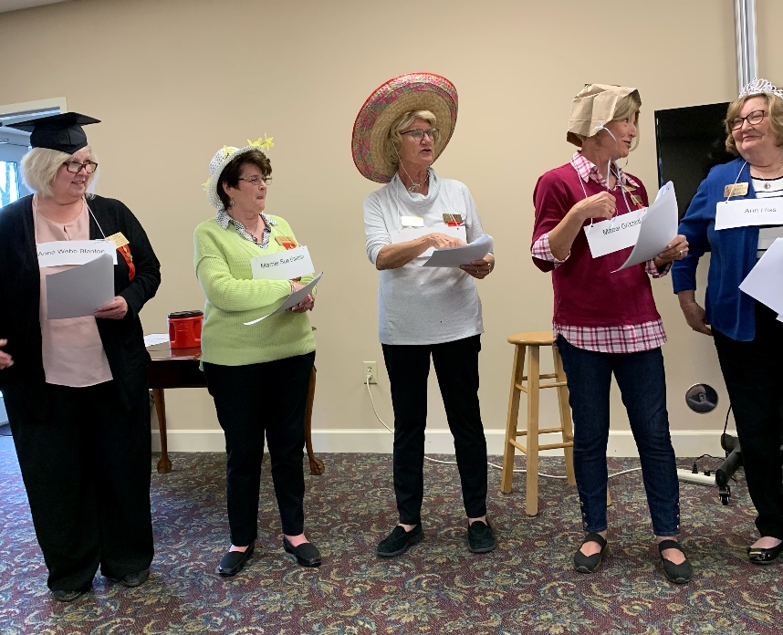
Alabama State DKG members perform a Founders Day skit, “Hats Off to Our 12 Founders”
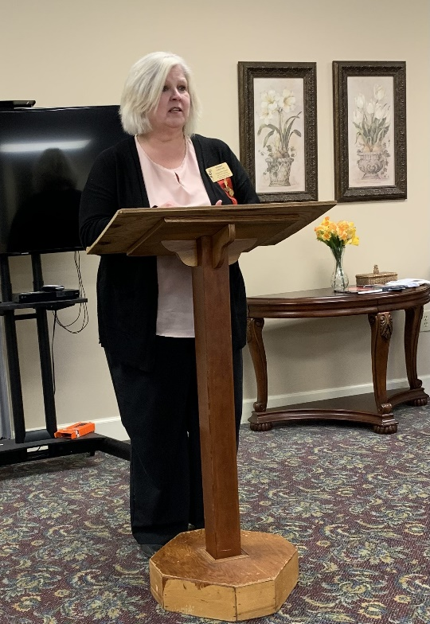
Alabama State President Penny Christian speaks to Gamma Beta and Mu chapters

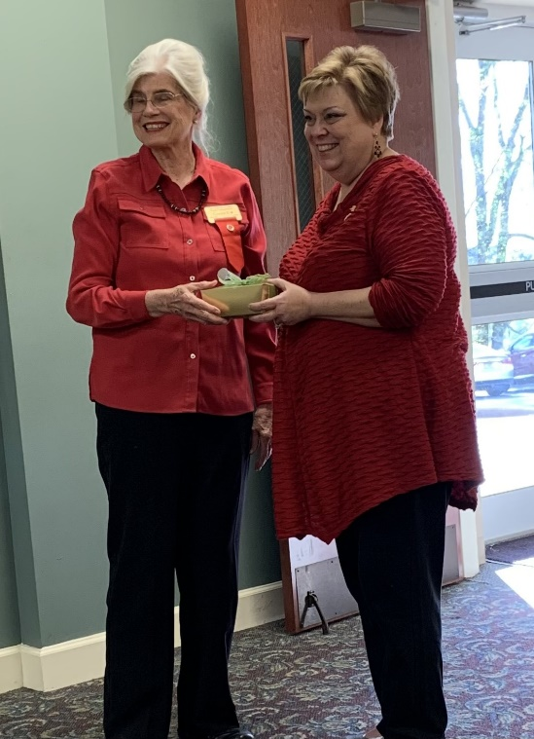
Jeanne Ellen presents a gift to our District 1 Director, Carolyn Eck

Gamma Beta members organized a Silent Auction with Mu. $453 was raised for our chapter due to the efforts of our members.

Gamma Beta Website
Send photos and information to Debby at dmcrow56@gmail.com.
http://gammabetachapter.weebly.com/

Alabama State

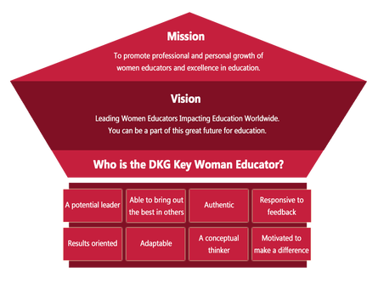
Alabama State offers scholarships to its members. The application for the scholarship will be included in the Sister Network. Last year Alabama State gave away zero dollars in scholarship money. Why? Because nobody applied. The deadline for scholarship application is February 1st.

Put March 3-5, 2023 on your calendar for the Alabama DKG State Convention in Tuscaloosa.

October
25th Debby Crowell

November
8th Sherri Peck
27th Carolyn Ellinger

October Meeting

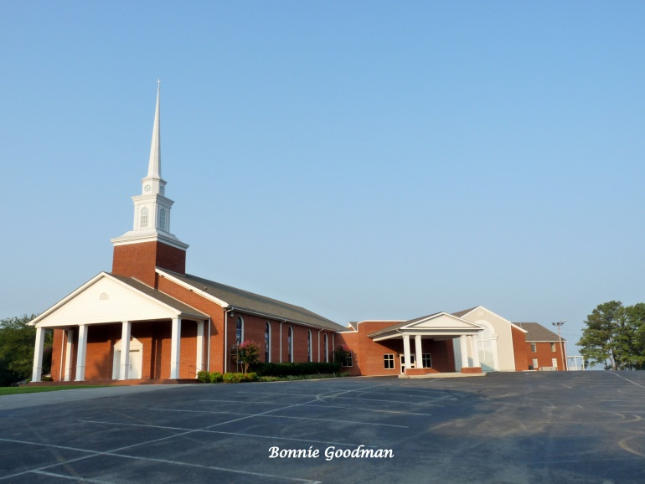
October 6, 2022
4:30 PM
Thursday
West Hartselle Baptist Church
1640 Main St. W.
Hartselle, AL 35640

Devotion: Sherri Peck
Business:
- Supporting Early Educators Grant Committee
- Gamma Beta Projects
- Gamma Beta Scholarship Committee
- Yearbooks
- Approve 2022-2023
Program:
- Salad Dinner
- Professional interest and position of women in Education
- World Fellowship Collection

Hostesses for this meeting: Lane Hampton chair, Ginger Richey, Sherri Peck, Carolyn Ellinger, Elizabeth Weinbaum
*All members bring a salad to share. Hostesses will provide drinks.

2022-2023 Chapter Meetings and Important Dates

- October 6, 2022 – Gamma Beta Salad Supper meeting – West Hartselle Baptist Church
- October 14-16, 2022 – WOW – Muscle Shoals
- November 3, 2022 – Gamma Beta meeting – West Hartselle Baptist Church – Christmas craft
- December 3, 2022 – Christmas Brunch – Home of Debby Crowell
- February 1, 2023 – Deadline for Alabama State’s scholarship application submission
- February 3, 2023 – Gamma Beta Meeting – West Decatur Elementary School – Team Building
- March 2, 2023 – Gamma Beta Meeting – Athens State University
- March 3-5, 2023 – Alabama DKG State Convention - Tuscaloosa
- April 6, 2023 – Joint meeting with Mu Chapter – West Hartselle Baptist Church

